FCPS
Java
Packets

Unit Two – Graphics and Animation

October 2018

Developed by Shane Torbert
edited by Marion Billington
under the direction of Gerry Berry

Thomas Jefferson High School for Science and Technology

Fairfax County Public Schools

Fairfax, Virginia

Contributing Authors
The author is grateful for additional contributions from Marion Billington, Charles Brewer, Margie Cross, Cathy Eagen, Philip Ero, Anne Little, John Mitchell, John Myers, Steve Rose, Ankur Shah, John Totten, and Greg W. Price.

The students' supporting web site can be found at http://academics.tjhsst.edu/compsci/
The teacher's (free) FCPS Computer Science CD is available from Stephen Rose (srose@fcps.edu)

License Information
This work is licensed under the Creative Commons Attribution-Noncommercial-No Derivative Works 2.5 License. To view a copy of this license, visit http://creativecommons.org/licenses/by-nc-nd/2.5/ or send a letter to Creative Commons, 543 Howard Street, 5th Floor, San Francisco, California, 94105, USA.

You are free:

* to Share -- to copy, distribute, display, and perform the work

Under the following conditions:

* Attribution. You must attribute the work in the manner specified by the author or licensor.
* Noncommercial. You may not use this work for commercial purposes.
* No Derivative Works. You may not alter, transform, or build upon this work.
* For any reuse or distribution, you must make clear to others the license terms of this work.
* Any of these conditions can be waived if you get permission from the copyright holder.

You are free to alter and distribute these materials within your educational institution provided that appropriate credit is given and that the nature of your changes is clearly indicated. As stipulated above, you may not distribute altered versions of these materials to any other institution. If you have any questions about this agreement please e-mail smtorbert@fcps.edu
Java Instruction Plan—Unit Two
Section One – Graphics | Page
Lab00: Hello World . . . . . . . . . . . . . . . . . . . . . . . . . . . . . . . . . . . . . . . . . . . . . | Two-3
Lab00modify: Graffiti . . . . . . . . . . . . . . . . . . . . . . . . . . . . . . . . . . . . . . . | Two-5
Lab01: Welcome Home . . . . . . . . . . . . . . . . . . . . . . . . . . . . . . . . . . . . . . . . . | Two-8
Lab02: Our Fearless Leader . . . . . . . . . . . . . . . . . . . . . . . . . . . . . . . . . . . . . . . | Two-11
Lab03: Webbing and Sunshine . . . . . . . . . . . . . . . . . . . . . . . . . . . . . . . . . . . . . | Two-14
Section Two – Static vs. Instance, Class vs. Object
Lab04: Buckets, Part I. . . . . . . . . . . . . . . . . . . . . . . . . . . . . . . . . . . . . . . . . . . . | Two-16
Lab04a: Buckets, Part II . . . . . . . . . . . . . . . . . . . . . . . . . . . . . . . . . . . . . . . . . . | Two-17
Lab05: Bugs . . . . . . . . . . . . . . . . . . . . . . . . . . . . . . . . . . . . . . . . . . . . . . . . . . . | Two-19
Lab06: Square Turtles . . . . . . . . . . . . . . . . . . . . . . . . . . . . . . . . . . . . . . . . . . . . | Two-23
Lab07: Polygon Turtles . . . . . . . . . . . . . . . . . . . . . . . . . . . . . . . . . . . . . . . . . . | Two-28
Lab08: Flower Turtles . . . . . . . . . . . . . . . . . . . . . . . . . . . . . . . . . . . . . . . . . . . . | Two-29
Lab09: Twisty Turtles . . . . . . . . . . . . . . . . . . . . . . . . . . . . . . . . . . . . . . . . . . . | Two-31
Section Three – Animation
Lab10: Polka Dots . . . . . . . . . . . . . . . . . . . . . . . . . . . . . . . . . . . . . . . . . . . . . . . | Two-34
Lab11: Bouncing Ball . . . . . . . . . . . . . . . . . . . . . . . . . . . . . . . . . . . . . . . . . . . | Two-37
Lab12: Get the Prize . . . . . . . . . . . . . . . . . . . . . . . . . . . . . . . . . . . . . . . . . . . . . | Two-38
Lab13: Project: Riddle Me This . . . . . . . . . . . . . . . . . . . . . . . . . . . . . . . . . . . | Two-39
Lab14: Bumper with Prize . . . . . . . . . . . . . . . . . . . . . . . . . . . . . . . . . . . . . . . . | Two-40
Lab15: Karel the Robot . . . . . . . . . . . . . . . . . . . . . . . . . . . . . . . . . . . . . . . . . . . | Two-42
Lab16: Mouse Input . . . . . . . . . . . . . . . . . . . . . . . . . . . . . . . . . . . . . . . . . . . . . | Two-43
Lab17: Keyboard Input . . . . . . . . . . . . . . . . . . . . . . . . . . . . . . . . . . . . . . . . . . . | Two-44
Lab18: Turtle, from scratch . . . . . . . . . . . . . . . . . . . . . . . . . . . . . . . . . . . . . . . | Two-46
Lab19: Array of Polkadots . . . . . . . . . . . . . . . . . . . . . . . . . . . . . . . . . . . . . . . . | Two-48
Lab20: Array of Prizes . . . . . . . . . . . . . . . . . . . . . . . . . . . . . . . . . . . . . . . . . . . | Two-49
Discussion
Panels and Frames
Robot worlds in JKarel were depicted in graphics windows. Graphics windows are created as instances of the class JFrame. A frame is a window with a border and a title bar. Content is made visible on frames using panels. Whatever you want the user to see is placed on a panel and that panel is placed on a frame.
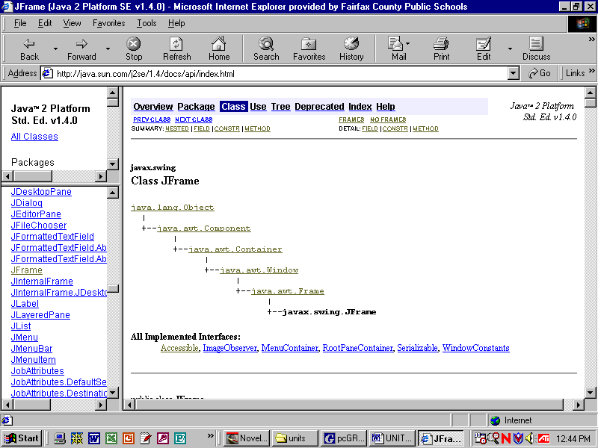
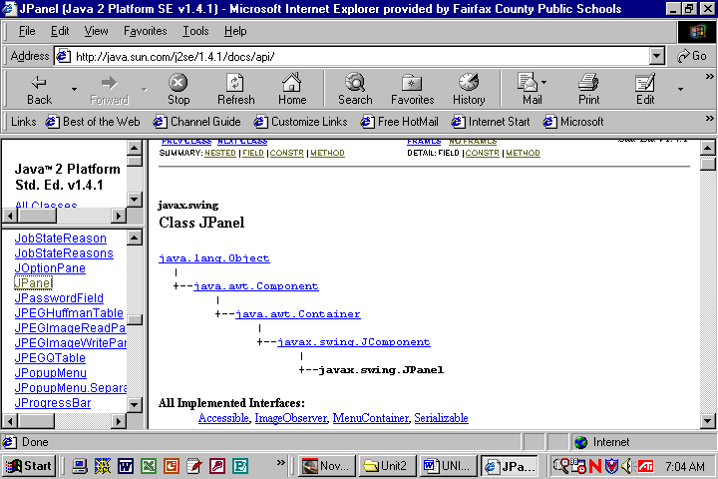
The class hierarchies from the Java API are shown below. Fortunately, because of object-oriented programming, you don't have to know the details of each class! Each of your driver programs will create a frame. In your graphics programs, each frame object will instantiate a panel object. The panel class that you make will inherit lots of functionality from the hierarchy. As you know, inheritance uses the keyword “extends”:
public class Panel00 extends JPanel
Panel00

Notice that Panel00 isa JPanel isa JComponent isa Container isa Component isa Object.
Note that a frame is able to hold panels because each frame is also a container. Eventually we will use a panel’s container ability to hold sub-panels.
new Panel00(); JFrame frame = new JFrame("Lab00"); frame.setContentPane(new Panel00);
(0,0)
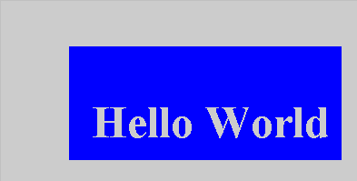
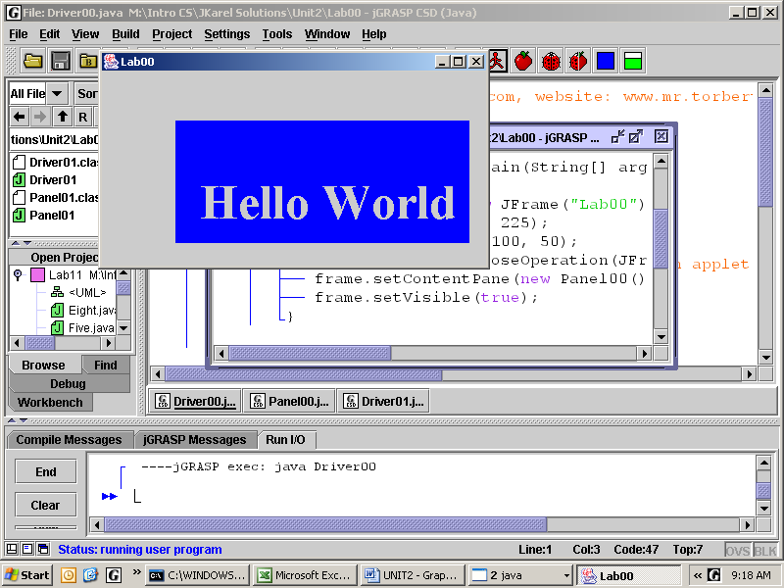
(0,0)

(0,200)
(0,225)
The graphics coordinate system treats the upper-left corner of the panel as (0, 0). As you move horizontally to the right the x-values increase—this should be exactly as you are accustomed. As you move vertically down the y-values increase—this should be exactly backwards from what you are accustomed.
The reason the origin is placed at the upper-left corner rather than the lower-left corner is so that the origin remains fixed even when the user resizes the frame. Users typically manipulate the bottom-right corner in order to resize a frame.
Lab00
Hello World
Objective
The difference between a driver and a resource.
Background
In our graphics programs we have two files, a driver class and a resource class. The driver sets up the JFrame and instantiates the panel. The panel is the resource where all the action happens.
Line 4: The driver imports some classes from the javax.swing package.
4 import javax.swing.JFrame;
5 public class Driver00
6 {
7 public static void main(String[] args)
8 {
9 JFrame frame = new JFrame("Lab00");
10 frame.setSize(400, 225);
11 frame.setLocation(100, 50);
12 frame.setDefaultCloseOperation(
JFrame.EXIT_ON_CLOSE);
13 frame.setContentPane(new Panel00());
14 frame.setVisible(true);
15 }
16 }

Line 7: Each application begins at the main method.
Lines 9-14: Instantiates the frame object. Then it sends messages to that frame object.
Line 13: The frame gets its content from the panel object. The panel's paintComponent is called automatically.
Lines 1-2: The panel class imports swing classes and Abstract Windowing Toolkit classes.
1 import javax.swing.*;
2 import java.awt.*;
3 public class Panel00 extends JPanel
4 {
5 public void paintComponent(Graphics g)
6 {
7 g.setColor(Color.BLUE);
8 g.fillRect(75, 50, 300, 125);
9 g.setFont(new Font("Serif",
Font.BOLD, 50));
10 g.setColor(new Color(150, 150, 0));
11 g.drawString("Hello World", 100, 150);
12 }
13 }

Line 3: Inherits lots of stuff from JPanel.
Line 5: Overrides JPanel's paintComponent method. The g object has already been created somewhere up in the JPanel hierarchy. Since the code compiles, we know that g has access to all the methods of a Graphics object.
Lines 7-11: Sends messages to the g object. These messages are graphics commands. What does a graphics object know?
Graphics programs typically have lots of classes and objects. Make sure you save both your class files in the same folder, Unit2\Lab00. You may have to ask your teacher how to get the students' shells for Unit2.

Specification
Create both Unit2\Lab00\Driver00.java and Unit2\Lab00\Panel00.java. Enter the source code shown above, then compile and run the driver. After that works, experiment.

Sample Run
Unit2Lab00.jar
Lab00modify
Graffiti

Objective
To apply your understanding of color, font, and drawString commands.

Color
In Lab00 you created a new Color object (it was gold) with the constructor new Color(150, 150, 0). Indeed, you can create any color by specifying the red-green-blue values, which are integers between 0 and 255. There are many color-pickers online. Here is one: http://www.colorspire.com/rgb-color-wheel/ Notice that any color is a combination of red-green-blue values. (0, 0, 0) is black. (255, 255, 255) is white. In hexadecimal values, black is #000000 and white is #FFFFFF. Play with the color-picker.

Java’s Color class also predefines thirteen color constants: BLACK, BLUE, CYAN, DARK_GRAY, GRAY, GREEN, LIGHT_GRAY, MAGENTA, ORANGE, PINK, RED, WHITE, and YELLOW. To set the color to red, you may use either g.setColor(Color.RED); or g.setColor(new Color(255,0,0));

To set a darker shade of red: g.setColor(Color.RED.darker());

To set a brighter shade of red: g.setColor(Color.RED.brighter());

After you set a color, everything is drawn or written in that color until you change it.

Font
The Font constructor takes three arguments, the style, whether plain, bold, or italic, and the size. To set a Serif, plain, small font, use g.setFont(new Font("Serif", Font.PLAIN, 8));

To create a font object that is SansSerif, bold, and large, use:
Font f2 = new Font("SansSerif", Font.BOLD, 20);
g.setFont(f2);

Two more examples:
Font f3 = new Font("Monospaced", Font.ITALIC, 12);
Font f4 = new Font("Arial", Font.BOLD | Font.ITALIC, 60);
baseline
yẼS
(x, y)

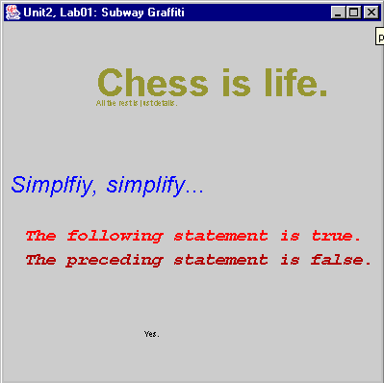
Words or Text
drawString takes three arguments, a String and
an (x, y) pair of coordinates, which specify the
position of the baseline of the string, as shown.
Specification
Create Unit2\Lab00\Driver00.java. Modify the file as needed.

Create Unit2\Lab00\Panel00modify.java. You may save Panel00.java as Panel00modify.java and modify the file. Display your favorite phrases, sayings, or quotes in the graphics window. Use at least four different colors, at least one user-defined color, at least four different fonts, all the possible font styles, and at least four different sizes.
Exercises
Lab00
Answer these questions about the Java API. The API (Application Programming Interface) is a document which lists and describes all you need to know about certain classes. The Java API for your version of Java is available on-line through any web browser. In jGrasp, go to Help|Java API.
1) What is a “constructor”?
建構子（Constructor）是一種特殊的方法，當物件被創建時會自動執行。它的名稱與類別名稱相同，且沒有回傳值。建構子通常用來初始化物件的屬性。

2) How many constructors does JPanel define? _4_
https://docs.oracle.com/javase/8/docs/api/javax/swing/JPanel.html

3) What does it mean “to implement an interface”?
介面定義的一些方法，類別必須實作這些方法，但介面本身並不包含實際的方法實現。

4) How many interfaces does JPanel implement? _4_
5) What are “instance methods”?
實例方法（Instance Methods）是屬於物件（Instance）的方法，必須透過物件來呼叫，而不能直接使用類別名稱呼叫。

6) How many instance methods does JPanel define? _很多_
7) What is a “superclass”?
超類別（Superclass） 是指被其他類別繼承的類別，也稱為父類別。

8) What is the superclass of Graphics? __Graphics 的超類別是 Object（所有 Java 類別的根類別）__
9) What is a “subclass”?
子類別（Subclass） 是繼承自某個父類別的類別。

10) How many known subclasses does Graphics have? _2_
11) Is g actually a Graphics object? Y/N How do you know?
N。通常 g 是 Graphics 類別的參考（reference），但它實際上通常指向的是 Graphics2D 物件。例如：Graphics g = new Graphics2D();

12) What is an “argument” (in Computer Science)?
參數（Argument） 是傳遞給方法或建構子的輸入值。

13) How many arguments does the drawLine method require?_4_
14) Why should you not use the method getClipRect?
因為 getClipRect() 已經被標記為 "deprecated"（不建議使用），可能在未來的 Java 版本中被移除。

15) Define “deprecated.”
deprecated（已棄用） 指的是 不建議使用的方法或類別，因為它可能：
- 有更好的替代方案。
- 存在安全性問題。
- 在未來版本中會被移除。

Discussion
Drawing Shapes
(x, y)
(x +100, 20)
(x, y+50)
Many of the drawing methods take four arguments, (x, y, width, length). The (x, y) establishes the absolute upper-left corner of the shape, and (width, length) are relative from that. The diagram shows example fillOval(20,20,100,50)

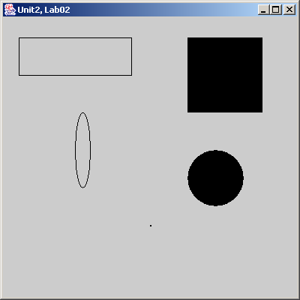
The following shapes take four arguments. Note the filled form of the commands to produce filled rectangles and ovals. Make sure you know how the numbers work!
Rectangle | g.drawRect(50, 50, 400, 75);
Square | g.fillRect(500, 50, 200, 200);
Ellipse | g.drawOval(200, 200, 20, 80);
Circle | g.fillOval(500, 300, 100, 100);
Point | g.drawRect(400, 600, 1, 1);

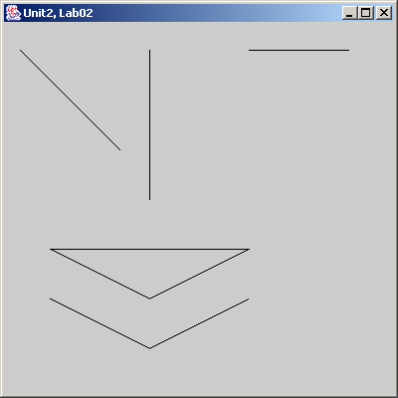
In these shapes, the pairs of arguments refer to (x, y) coordinates that are endpoints of the line segments. All four coordinates are absolute.

Line | g.drawLine(20, 50, 120, 150);
Vertical Line | g.drawLine(150, 50, 150, 200);
Horizontal Line | g.drawLine(250, 50, 350, 50);
Polygon | int xPoints[] = {50, 150, 250};  int yPoints[] = {250, 300, 250};  g.drawPolygon(xPoints, yPoints, 3);
Polyline | int xxPoints[] = {50, 150, 250};  int yyPoints[] = {300, 350, 300};  g.drawPolyline(xxPoints, yyPoints,3);
Note that the third argument to polygon and polyline is the number of points that make up the polygon or polyline. This value will be equal to the length of each array xPoints and yPoints. The difference in these two commands is that a polygon automatically connects the last point back to the first; a polyline does not. Be careful! The order of the points for a polygon makes a difference. For instance:
P₀
P₂
P₁
P₀
P₁
P₃
P₃
P₂
Lab01
Welcome Home
Objective
To create graphics using Java's drawing commands.
Specification
Create a new Java driver and panel in folder Unit2\Lab01. Reproduce the house below. Use the given coordinates. To see the colors, please run the .jar file.

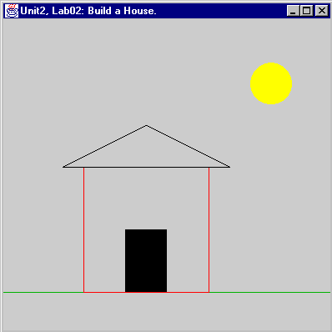
Welcome Home
(0,0)
g.fillOval(300, 75, 50, 50);

(40, 40)

(75, 200)
(175, 150)

g.drawRect(100, 200, 150, 150);
(275, 200)

g.fillRect(150, 275, 50, 75);

(400, 350)

(400, 400)
(0, 350)

Sample run
Unit2Lab01.jar

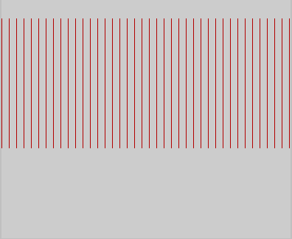
Discussion
Loops and graphics

Loops can be used to draw repeating shapes. The code below draws the repeating vertical lines as shown at the right.
for(int x = 0; x <= 400; x += 10)
g.drawLine(x, 25, x, 200);
By looking at the code, how do you know they are vertical lines?
Note that the y-values of the endpoints are always 25 and 200. The x-values of the endpoints are always the same number (for each line), and this number increases by 10 with each iteration of the loop, producing x values of 0, 10, 20, 30, …, 400. These two lines of code draw the forty-one lines you see on the panel. It is as if we had written out forty-one different drawLine commands, but it only took us two lines of code. Oh, the power of a for-loop!

Lab01 continued
Welcome Home with loops
Specification
- Return to Lab01 and draw a picket fence, using a for-loop, in front of your house in Lab01. When you finish, write the for-loop for your picket fence here:
for(int a = 0; a < 16; a++){
int x = a*25;
g. fillRect (x, 300, 5, 100);
}
- Use a for-loop to draw repeated horizontal ovals for clouds. When you finish, write the code for your clouds:

- Write the for-loops that produced the horizontal clouds shown below.
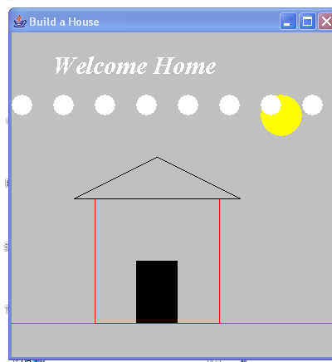 | 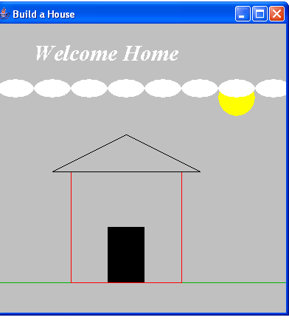 | 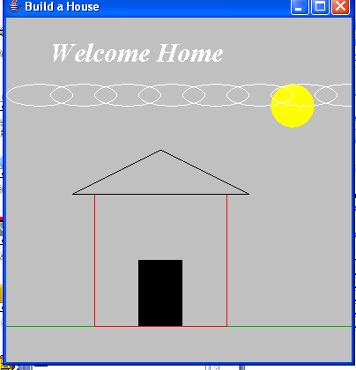
for(int a = 0; a < 8; a++){  int x = a*50;  g. fillOval(x, 75, 20, 20);  } | for(int a = 0; a < 8; a++){  int x = a*50;  g. fillOval(x, 75, 50, 20);  } | for(int a = 0; a < 8; a++){  int x = a*50;  g. drawOval (x, 75, 70, 20);  }

- Now return to the house in Lab01 and make it fancy. Use your imagination. Here are some pictures that students have produced in the past. These pictures, in color, are also in your Unit 2, Lab01 folder.
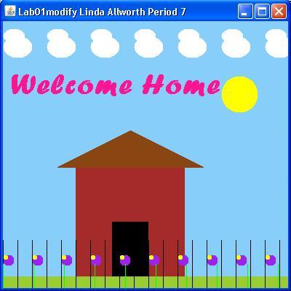 | 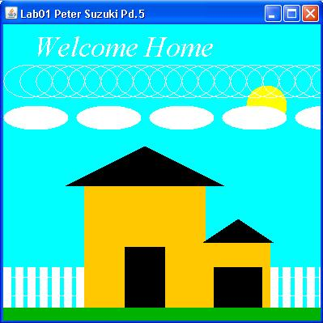 | 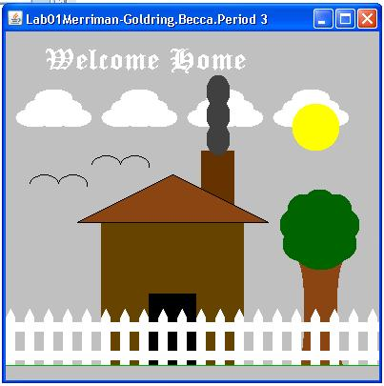
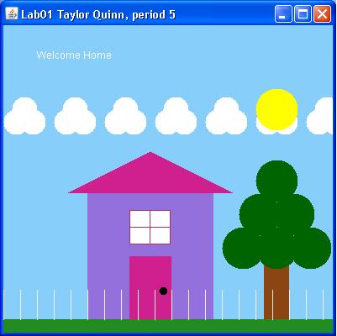 | 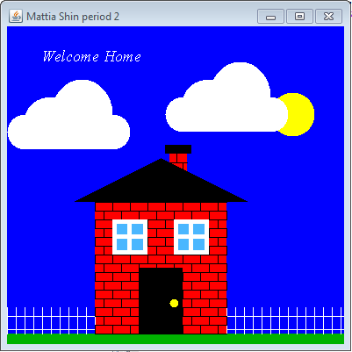 | 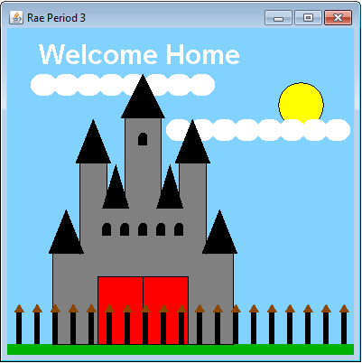
Exercises
Lab01
Using the Graphics object g, create the following shapes:

1) Draw a rectangle whose top-left corner is at position 50, 75 and whose width is 100 and height is 200.
g.drawRect(50, 75, 100, 200);

2) Draw a square whose top-left corner is at position 200, 150 and whose sides have a length of 100.
g.drawRect(200, 150, 100, 100);

3) Draw a line connecting the points 20, 40 with 120, 80.
g.drawLine(20, 40, 120, 80);

4) Draw a circle at position 50, 100 (position of top-left corner of imaginary rectangle in which the circle will be placed) with a width and height of 60.
50, 100
g.drawOval(50, 100, 60, 60);

5) Now draw that same circle except use 50, 100 as its center point.
int radius = 30;
g.drawOval(50 - radius, 100 - radius, 2 * radius, 2 * radius);

6) Draw an ellipse at position 100, 100 (position of top-left corner of imaginary rectangle in which the ellipse will be placed) with a width of 80 and height 30.
100, 100
g.drawOval(100, 100, 80, 30);

7) Now draw that same ellipse except use 100, 100 as its center point.
int ellipseWidth = 80, ellipseHeight = 30;
g.drawOval(100 - ellipseWidth / 2, 100 - ellipseHeight / 2, ellipseWidth, ellipseHeight);

8) Using your knowledge of the drawRect and drawLine methods, create the following figure whose top-left corner is at 20, 20 and whose width is 100 and height is 80. (Hint: First write the commands to draw the rectangle, then write the commands to draw the four lines inside the rectangle.) It might help to label the beginning and ending points of each of the 4 cross lines.
g.drawRect(20, 20, 100, 80);
g.drawLine(20, 20, 120, 100);
g.drawLine(120, 20, 20, 100);
g.drawLine(70, 20, 70, 100);
g.drawLine(20, 60, 120, 60);

Lab02
Our Fearless Leader
Objective
drawImage and fillOval

Background
Java uses an ImageIcon object to store a jpg, jpeg, gif, or png file:

ImageIcon thomas = new ImageIcon("tj.jpg");

For this to work there must be an image file named "tj.jpg" in your Unit2\Lab02 folder. This image can be displayed with its upper-left corner at (50, 50) by using one of the commands:

g.drawImage(thomas.getImage(), 50, 50, null); //original size
g.drawImage(thomas.getImage(), 50, 50, 25, 75, null); //scaled image

The arguments 25 and 75 scale the image to be 25 pixels wide by 75 pixels high. The null is a place-holder for an object that we don't care to instantiate. In this case, null means about the same as “empty.”

Note how different types of objects work together in order to make the image appear on the screen:

ImageIcon |  | Image |  | Graphics |  | JPanel |  | JFrame
object thomas is created | → | thomas knows its own image | → | g.drawImage gets thomas’s image | → | g paints the panel | → | the panel appears on the screen

The fillOval method can be used to draw circles. The method requires four arguments. The first two arguments specify the upper-left corner of the rectangle (or square) enclosing the oval (or circle). They do not specify the center of the circle. The last two arguments specify the width and height of the enclosing square, also known as the circle’s diameter. The last two arguments do not specify the radius of the circle. On the other hand, we often want to draw circles from the center with a certain radius. For a general circle with center at (x, y) and radius r, you may use: g.fillOval(x – r, y – r, 2 * r, 2 * r);. Of course, to use this formula, your code must assign concrete values to x, r, and y.

Be careful! The compiler will not compile 2r. You must write 2 * r.

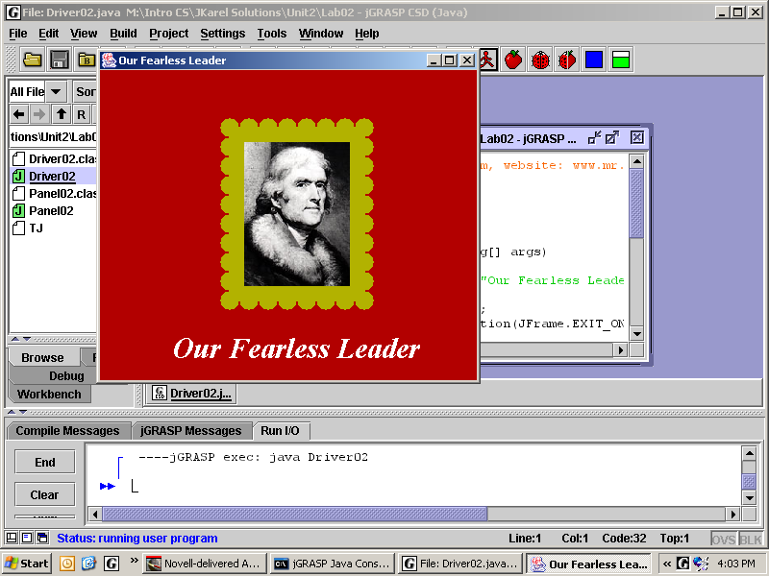
If you can make the x change regularly, using a for-loop, you can draw a horizontal row of repeated circles for a frame effect. How do you draw a vertical row of circles?

Specification
Run Unit2Lab02.jar . Duplicate the image. The frame is gold and the background is red.

Create filename Unit2\Lab02\Driver02.java. Make sure to add a panel object of type Panel02.

Create filename Unit2\Lab02\Panel02.java. Use graphics commands to draw a framed picture of your school’s namesake, principal, or inspirational leader. Estimate all distances by trial-and-error.
Exercises
Lab02
Using the Graphics object g, create the following shapes:

1) Use a for-loop to create the following image. Each line is 50 pixels long and 5 pixels apart. The top of the first line is at 80, 50.
for (int i = 0; i < 8; i++) {
int x = 80 + i * 5;
g.drawLine(x, 50, x, 100);
}

2) Use a for-loop to create the following image. Each circle is green, 20 pixels wide, and the first circle on the left has an upper-left corner position of 100, 0.
g.setColor(Color.GREEN);
for (int i = 0; i < 5; i++) {
int x = 100 + i * 20;
g.fillOval(x, 0, 20, 20);
}

3) Use a for-loop to create the following image. Each circle is magenta, 20 pixels wide, and the top circle has an upper-left corner position of 100, 100.
g.setColor(Color.MAGENTA);
for (int i = 0; i < 5; i++) {
int y = 100 + i * 20;
g.fillOval(100, y, 20, 20);
}

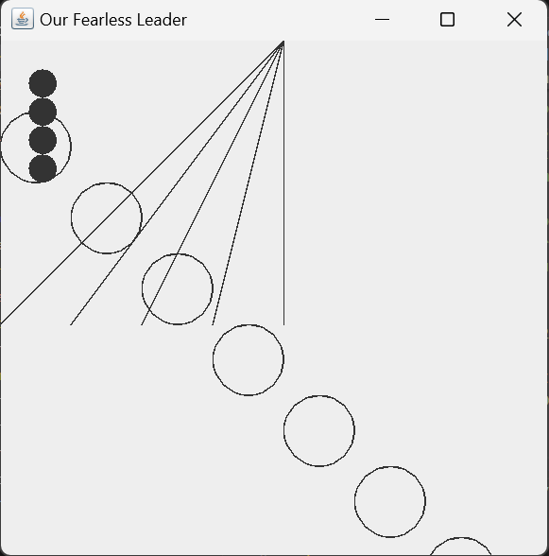
0,0

4) Draw the output of this command:
for(int y = 0; y < 5; y++)
g.drawLine(200, 0, y*50, 200);

5) Draw the output of this command:
for(int y = 20; y <= 80; y+=20)
g.fillOval(20, y, 20, 20);

6) Draw the output of these commands:
int y = 0;
for(int x = 0; x < 400; x+=50)
400, 400
g.drawOval(x, y+=50, 50, 50);

Discussion
Buffering an image
Up to now, we drew graphics directly on the panel by sending commands to the g object in paintComponent. Starting with Lab03 we will draw the image in an off-screen buffer, or temporary storage area, and then “paste” the complete image on the screen once at the end. Drawing to a buffer is much faster than drawing to the screen. When we start animation, with lots of drawing commands, using the buffer eliminates images that flicker.
Lines 9 and 10 declare two private fields (variables) in this object, N and myImage. Line 9 also declares N, which is the size of the panel, as final, meaning that N is a constant in the code. (N is a constant, even though a user can change the size of panel by clicking and dragging a corner.) Line 10 creates a reference but does not assign an object. Line 12 begins the constructor. Line 14 actually instantiates and assigns the BufferedImage object to the reference that is on Line 10. Line 15 gets the Graphics object that is inside the BufferedImage object and assigns a reference called buffer. Beginning on Line 16, we send the familiar drawing, color, font, and drawString commands to the buffer object.
6 import java.awt.image.BufferedImage;
7 public class Panel03 extends JPanel
8 {
9 private final int N = 400;
10 private BufferedImage myImage;
12 public Panel03()
13 {
14 myImage = new BufferedImage(N, N, BufferedImage.TYPE_INT_RGB);
15 Graphics buffer = myImage.getGraphics();
16 buffer.setColor(Color.BLUE);
17 buffer.fillRect(0, 0, N, N);
All the graphics commands work exactly as you would expect them to. The only difference is that you are sending messages to the buffered object. In order to actually see what you've drawn, you must “paste” the buffered image onto the panel, using one command in paintComponent:

public void paintComponent(Graphics g)
{
g.drawImage(myImage, 0, 0, getWidth(), getHeight(), null);
}

The methods getWidth and getHeight return the current width and height of the panel. These values may change during runtime if the user resizes the frame. When you resize, the image will change to fill up the panel.

The different objects work together in this fashion:

BufferedImage |  | Graphics |  |  |  | Graphics |  | JPanel |  | JFrame
Creates myImage buffered in memory. | → | Gets the buffered object. | → | Use the normal Graphics commands | → | g gets the image in myImage | → | paints the panel | → | Displays the panel on the screen

There is a shell for Lab03 that has this off-screen buffer already set up for you. Don’t change it!
Lab03
Webbing and Sunshine
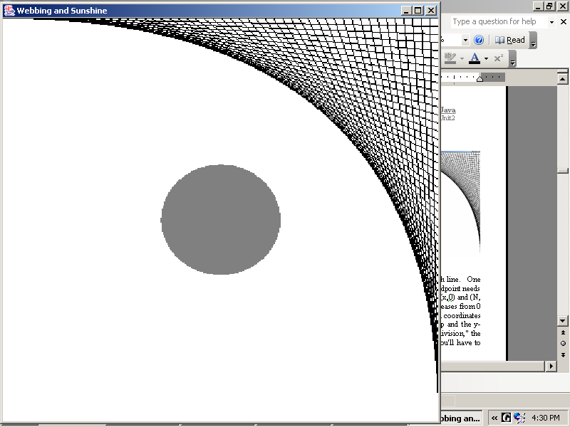
Objective
Calculating end-points and using drawLine
Background
The first task is to draw webs at the corners. This for-loop draws a web in the upper-right corner of the N x N image:
for(int k = 0; k <= 50; k++)
{
buffer.drawLine(N * k / 50, 0, N, N * k / 50);
}
Notice that 51 lines will be drawn. drawLine takes two pairs of coordinates, the end points of each line. One endpoint of each line needs to move from left to right across the top of the image while the other endpoint needs to move from top to bottom down the right side of the image. If we can make x increase, then (x, 0) will slide the top endpoint over. At the same time, an increasing y will slide (N, y) down. We can make x and y increase in a for-loop, for as k increases from 0 to 50, the expression N * k / 50 increases from 0 to N in 50 equal increments. Thus, the calculated coordinates (N * k / 50, 0) and (N, N * k / 50) together slide the x-coordinate of the first point along the top and the y-coordinate of the second point down the right side. (Warning! Due to something called "integer division," the expression k / 50 * N will evaluate to 0. Make sure to multiply N * k before dividing by 50.) You'll have to figure out how to move the endpoints for the other three corners.
x1, y1
x1, y1
The second task is to draw the rays of the sun. The center is at (x, y) but each of the other endpoints must be calculated. From geometry, we know that in any right triangle the sine of an angle is the ratio of its opposite side to its hypotenuse and the cosine of an angle is the ratio of its adjacent side to its hypotenuse. This means that if we know the angle and the length of the hypotenuse, we can determine the lengths of the opposite and adjacent sides, which are the coordinates (x1, y1). The angle θ changes from 0 to 360 in equal increments, depending on how many rays we want. We'll use a for-loop to change the angle, of course. Inside the for-loop we will calculate the (x1, y1) coordinates and draw the line.
x, y
θ
x1, y1
x1, y1
It happens that Java's Math.cos and Math.sin methods require radian arguments. Since most people prefer to think in degrees, we multiply degree measures by Math.PI / 180. Also, these trigonometry methods return decimal values, so we need to cast the coordinates to integers using (int). For example:
x1 = (int)(x + size * Math.cos(angle * Math.PI / 180));
Specification
Create Unit2\Lab03\Driver03.java. Make an appropriate driver, then compile and run.

Load Unit2\Lab03\Panel03.java. Complete the definition of the constructor to draw the full, four-cornered webbing and a sun with rays. Draw 12 rays at first, but make it easy to draw any number of rays.

Extension
Change all constants into variables. Prompt the user to enter N, the number of lines, and the number of rays. You will need Integer.parseInt, which turns a string into an int.

Sample Run Unit2Lab03.jar
Exercises
Lab03
Complete these questions using the Java API.

1) A field in Java is a variable created and used by a class. How many fields are in the Math class?_2_
https://docs.oracle.com/javase/8/docs/api/java/lang/Math.html

2) What two numbers are stored in the fields of the Math class?
Math.PI（圓周率 π，約為 3.141592653589793）
Math.E（自然數e，約為 2.718281828459045）
3) The Math class fields are marked public static final double. Explain what each word means.
public：此欄位是公有的，任何類別都可以存取它。
static：此欄位屬於類別（class）而不是某個物件，因此可以直接使用 Math.PI 而不需要建立 Math 物件。
final：此欄位的值是不可更改的常數，一旦賦值後就不能修改。
double：欄位的資料型態是雙精度浮點數，適合儲存精確的數學常數。
4) Explain why it makes sense that π and e are public static final double in Java.
同3)。

5) How many constructors does the Math class define? _0_Why does that make sense?
因為 Math 類別的方法和欄位都是 static 的，不需要建立 Math 物件，所以不提供建構子。

6) What does a void method do?
void 方法不回傳值，它只執行某些操作，沒有 return。

7) How many void methods does the Math class define? _0_

8) Explain the Computer Science meaning of “to pass an argument.”
將值提供給方法，以便該方法使用該值來執行計算或操作。

9) How many no-argument methods does the Math class define? _1_ Name them __Math.random() __

10) Why can’t you create a Number object?
Number 是抽象類別（abstract class）。

11) How many direct known subclasses does Number have? _6_

12) How many interfaces does Integer implement? _4_ Name them __ Comparable<Integer>、Serializable、
Constable、 ConstantDesc __

13) How many constructors does Integer define? _1_

14) What do you think an Integer constructor does?
建立一個 Integer 物件，封裝 int 值。
Lab04
Buckets
Objective
Class methods vs. instance methods

Background
Here is a classic logic problem: given two buckets, a 3-gallon bucket and a 5-gallon bucket, how can you measure out exactly 4 gallons?
5 import javax.swing.*;
6 import edu.fcps.Bucket;
7 public class Driver04
8 {
9 public static void main(String args[])
10 {
11 JFrame frame = new JFrame("Buckets");
12 frame.setSize(600, 400);
13 frame.setLocation(100, 100);
14 frame.setDefaultCloseOperation(
JFrame.EXIT_ON_CLOSE);
15 frame.setContentPane(new BucketPanel());
16 frame.setVisible(true);
17 Bucket.setSpeed(1);
18 Bucket.useTotal(false);
19 Bucket five = new Bucket(5);
20 Bucket three = new Bucket(3);
21 // implement the algorithm here
22
23

The algorithm to implement is:
- Fill the five-gallon bucket.
- Pour from five into three until three is full.
- Empty the three-gallon bucket.
- Pour from five into three until five is empty.
- Fill the five-gallon bucket.
- Pour from five into three until three is full.
- Done! The amount left in five is exactly 4.

The edu.fcps.Bucket class gives you the tools to program a solution. As you might expect, the Bucket class allows you to instantiate bucket objects, to fill them up, and to pour them out. The class also draws the buckets on a table, shows the water levels rising and falling, and tracks the number of gallons by turning white numbers to red. You look up the methods in the Bucket class by going to its API at https://academics.tjhsst.edu/compsci/CSweb/index.html .

On line 17, we see the class method Bucket.setSpeed(1). We know it is a class method because the dot notation is invoked on the class Bucket. The compiler knows it is a class method because of the keyword static
Bucket class
setSpeed(int s)
useTotal(boolean b)
public static void setSpeed(int s)
public static void useTotal(boolean b)

It should make sense that setSpeed would be owned by the Bucket class, not by the individual bucket objects. It should also make sense that the method pourInto would be owned by the individual bucket objects. If the individual objects own the method, it is called an instance method. The compiler knows it is an instance method because there is no static, e.g.
a Bucket object
pourInto(Bucket b)
fill()
spill()

public void pourInto(Bucket arg)
public void fill()
public void spill()

Static methods add powers to the class, not to the objects. Static methods remain with the class and do not get duplicated in each object. In consequence, there will be exactly one copy of setSpeed and it is owned by the Bucket class. However, there may be many of copies of pourInto, because each Bucket object owns its own copy of pourInto.

Specification: Write Driver04 to implement the algorithm to get exactly 4 gallons. Don’t change BucketPanel!
Sample Run Unit2Lab04.jar
Lab04
Buckets, Part II

Objective
Class fields vs. instance fields
Bucket class

Background
totalWater | 8
Bucket object |  |  | five
 |  |  | myWater | 5
Bucket object |  |  | three
 |  |  | myWater | 3
We instantiate two Bucket objects with:
Bucket five = new Bucket(5);
Bucket three = new Bucket(3);

The first part of the code in the Bucket class looks like:
public class Bucket
{
private static int totalWater;
private int myWater;
...
}
The keyword static causes the computer to create one copy of the static field totalWater and give it to the Bucket class. The lack of static causes the computer to create two copies of myWater and give one to each Bucket object. The Bucket class stores the total water (8) in the system in totalWater, while each Bucket object stores its own value in myWater (5 and 3).

On Line 18 in Driver04, you called the class method Bucket.useTotal(false). The effect of this mystery command was to turn off the static field totalWater. In consequence, the program kept track of the numbers in the instance fields of each bucket object. When either bucket held a certain number of gallons, it turned that number from white to red. Run it again and notice when the little white numbers turn red.
5 import edu.fcps.Bucket;
6 import javax.swing.*;
7 public class Driver04a
8 {
9 public static void main(String args[])
10 {
11 JFrame frame = new JFrame("Buckets");
12 frame.setSize(600, 400);
13 frame.setLocation(100, 100);
14 frame.setDefaultCloseOperation(
JFrame.EXIT_ON_CLOSE);
15 frame.setContentPane(new BucketPanel());
16 frame.setVisible(true);
17 Bucket.setSpeed(5);
18 Bucket.useTotal(true);
19 Bucket five = new Bucket(5);
20 Bucket three = new Bucket(3);
21 // implement the algorithm here
22
23
24

In contrast, line 18 in Driver04a has a call in to Bucket.useTotal(true). The effect of this mystery command is to turn on the static field totalWater, which keeps track of the total volume of water in all the buckets. In this case, when the water in the system holds a certain number of gallons, that number turns from white to red.

Specification
Modify Driver04, calling it Driver04a. This time track the total volume of water. Turn the white numbers to red, showing that the system can measure out 1, 2, 3, 4, 5, 6, 7, and 8 gallons.

Sample Run Unit2Lab04a.jar

Extension Create a new driver named Driver04b. Make three Bucket objects, of 3, 4, and 5 gallons. Track the total volume of water by turning the white numbers to red. Show that the system can measure out 1, 2, 3, 4, 5, 6, 7, 8, 9, 10, 11, and 12 gallons.
Exercises
Lab04
1) Given two buckets named five and six with capacities of five and six, respectively, produce exactly four gallons of water.

2) Given two buckets named four and five with capacities of four and five, respectively, produce exactly two gallons of water.

class Bucket
3) Here is the beginning of class Bucket:
a Bucket object
class Bucket
{
private static int totalWater = 0;
private static int numBuckets = 0;
private final int myCapacity;
private int myWater;
. . .
}
3a) Draw and label the class fields and the instance fields. Use the boxes above.
3b) What’s the purpose of totalWater? _____________________Who owns totalWater? ____________
3c) What’s the purpose of myCapacity? _____________________ Who owns myCapacity? ___________
3d) What’s the purpose of myWater ? __________________________
3e) The method fill has to change two fields. What are they? ________________and _______________.
3f) Each Bucket object has two private fields, myWater and myCapacity. When does the value of myWater change?

3g) Each Bucket object has two private fields, myWater and myCapacity. When does the value of myCapacity change?
When does the value of myCapacity get set?
4) Explain why it makes sense that setSpeed is a static method.

5) A certain class has the code for methods for public void aaa() and public static void bbb().
In the driver, you instantiate three objects from this class. How many copies of method aaa do you have? ____ How many copies of method bbb do you have? ____
Lab05
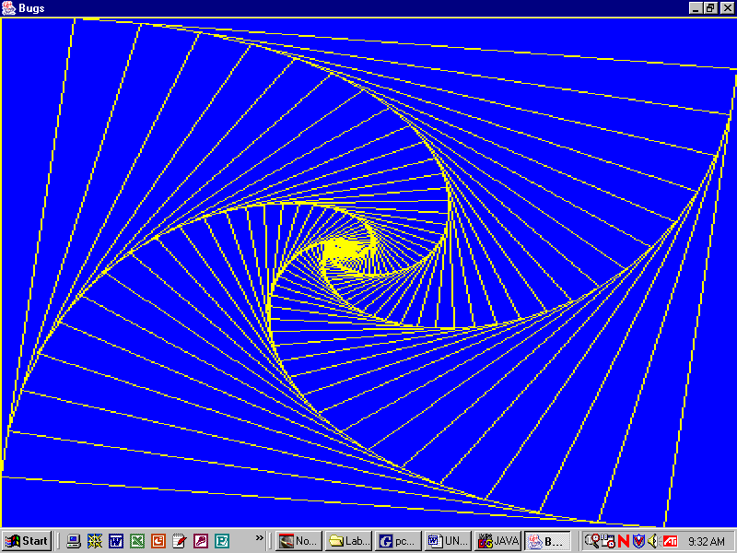
Bugs
Objective
An example resource class, Bug.
Background
The Bug class provides most of the tools to draw the spiral design. Like most of our classes, a Bug has private data and public methods. The private data is hidden from the user, but the public methods make that data available to the user. Programmers do it this way because it makes the code safer and easier both to use and to write.

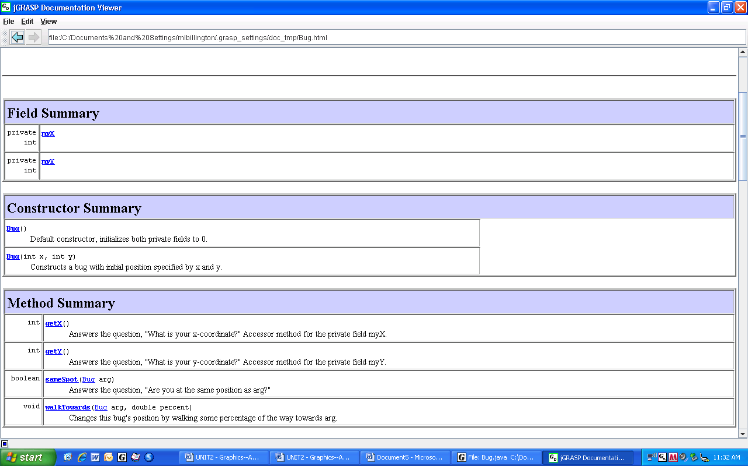
The API lists the public methods, which is what the user needs to know in order to use the object.
How do you instantiate bugs? By calling one of its constructors—of course!

What can bugs do? A Bug can tell you where it is. Each Bug has two public accessor methods getX and getY. Each returns an int.
What else can bugs do? A bug can report, either true or false (which are boolean values), whether it is at the same spot as another bug. You don’t know how the instance method sameSpot works, but you do need to know that it takes one argument, a Bug, and returns a boolean.
What else can bugs do? A bug can walk a percentage of the distance towards another bug. The instance method walkTowards requires two arguments, the other bug (the Bug arg) and a decimal number (the double percent) of the percentage of the distance to travel. It is a void method because it does not return anything.
Are bugs able to draw lines? Look at the API. No, bugs do not know how to draw lines. You have to invoke that command yourself on the buffer.
Specification
Load Filename Unit2\Lab05\Driver05.java and \Bug.java. Don’t change these!
Steps in the algorithm: | Write an example that calls the appropriate method:
- Instantiate 4 bugs, one at each corner.
- Tell each bug to move 10% of the way toward its clockwise neighbor.
- Draw a line between each bug.
- Repeat steps 2 and 3 until any two bugs are at the same spot.
Load Filename Unit2\Lab05\BugPanel.java. Implement the algorithm below:
Sample Run Unit2Lab05.jar
Exercises
Lab05
On the previous page we studied the API for Bug. Now study the source code for Bug. What do bugs know? What can they do to themselves?
1 public class Bug
2 {
3 private int myX;
4 private int myY;
5 public Bug()
6 {
7 myX = 0;
8 myY = 0;
9 }
10 public Bug(int x, int y)
11 {
12 myX = x;
13 myY = y;
14 }
15 public int getX()
16 {
17 return myX;
18 }
19 public int getY()
20 {
21 return myY;
22 }
23 public boolean sameSpot(Bug arg)
24 { //code not shown }
30 public void walkTowards(Bug arg,
double percent)
31 { //code not shown }
36 }
- Mark the private fields “F”, the constructors “C”, the accessor methods “A”, and the instance methods “I”.

- Do the Bug constructors use an explicit super command? Y/N Why or why not?

- The job of the constructor is to initialize the private data, meaning, to assign values to the
fields. Show where that happens in this code.

- Write the code to instantiate a Bug object named lady at position (0, 0).

- Write the code to instantiate a Bug object named june at position (37, 145).

6. Tell the june Bug to store its x-position in the variable temp.

7. Tell a bug named assassin to walk halfway towards a bug named bed.

It is helpful to picture the Bug class in an object diagram:
Bug
myX
myY

getX()
getY()
sameSpot()

- Why is the Bug class pictured inside a thick black box?

- Why are myX and myY shown entirely inside the box, but getX() and getY() extend outside the box?

- What is the advantage of making fields private, not public?

walkTowards()
- Modifier methods change data in an object’s fields. The name of a modifier method usually begins with "set". A modifier method also needs an argument. Write the code for a modifier method that modifies myX

Discussion
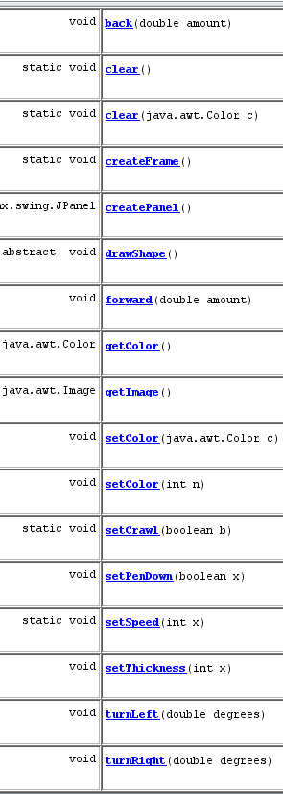
The Turtle class
In the early 1970s M.I.T. introduced a turtle to the LOGO language. Turtles are similar to Bugs and Robots, but are much more complex and powerful. What can Turtles do? Let's look at its API.

1. "static" means that the class owns one copy of each method. Circle the static methods. One of those static methods controls the speed at which the turtles move. Write the command to make the turtles move at speed 5.
__________________________
Hint: recall that the Turtle class "owns" the method.

2. Another class method turns the crawling off, which makes the turtles draw very fast indeed. Write that command here: ___________________

3. A third class method clears the screen and changes the background color. Change the background to white:
___________________________
4. The "non-static" methods are duplicated inside each turtle object. Star the four methods that actually control the turtle’s movements. Tell the SquareTurtle smidge to turn right 45 degrees: _________________

5. Tell smidge to leave a line as it walks forward 50 steps: _____________________
_____________________

6. Accessor methods get data from the object’s fields. They usually begin with "get". How many accessor methods are in each turtle object? ____

7. Modifier methods change data in an object’s fields. They usually begin with "set". Tell smidge to set its color to yellow and its marker thickness
to 10 pixels wide. ___________________
___________________
8. Which method is abstract? ________________ Since one method is abstract, the whole Turtle class is abstract, meaning that you can't instantiate any Turtle objects directly. Instead, you will extend the Turtle class into concrete subclasses, such as SquareTurtle, PolygonTurtle, and TwistyTurtle. In those subclasses, your job will be to write appropriate code in the drawShape method. What abstract classes have you implemented in previous labs? ____________________
Discussion
Classes, Abstract Classes, and Objects
When you first see a new class, the question you should always ask is: what can this class do to itself?
The Turtle class has both static and dynamic fields and methods. The static fields and methods stay with the class and the dynamic fields and methods are duplicated in each object.
The Turtle class has (at least) four static methods, which the class "knows." Class methods often affect the environment of the objects. The Turtle class has set-methods clear, setSpeed, and setCrawl that can change the data stored in three of the private static fields.
The Turtle class
private static: BGcolor , speed, crawl
private static: myImage

clear()
setSpeed()
setCrawl()
getImage()
The Turtle class is abstract because drawShape is abstract. Turtles do not know what shape to draw. The idea is that only the subclasses know what shape to draw.
Turtle
private:myX,myY,myH,
myColor, penDown,
forward()
setColor ()
drawShape()
computeHeading()
getColor()
turnLeft()
turnRight()
Even though Turtle is abstract, it is still convenient to give it several constructors (which we don't show in these class diagrams). Recall that constructors instantiate the object and initialize the private data. Turtle no doubt has a default constructor. The private fields inherited from Turtle store data about the turtle's position, heading, pen color, and pen state.
Any Turtle subclasses will have constructors with the super method which passes initial values to myX, myY, myH, myColor, and penDown.
Some public methods inherited from Turtle are simple get and set methods, but some are much more complex, such as turnLeft and forward.
SquareTurtle
private: mySize
setSize()
drawShape()
isa
Some private methods are also inherited from Turtle, such as computeHeading. There are probably several other private helper methods.
The SquareTurtle class, which inherits lots of functionality from Turtle, has one additional private field mySize and one additional set method. It has four constructors. SquareTurtle also implements Turtle's abstract drawShape method. SquareTurtles know how to draw squares.
A good assignment would be to write a two-page paper that compares and contrasts the designs of the Bug, Turtle, and Robot resource classes. Include a class diagram similar to that above illustrating the relationship between Robot and Athlete.
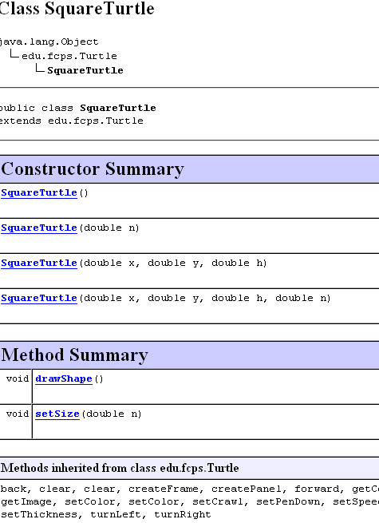
Lab06
Square Turtles
Objective
To understand the SquareTurtle class.

Background
Ideally, the API tells you everything you need to know to use SquareTurtle.
h stands for “heading.”
90 North

180 0
West East

270 South

Notice that SquareTurtle extends Turtle.

Notice the four constructors: a default, a one-arg, a three-arg, and a 4-arg constructor. These make it easy to instantiate SquareTurtles in different states, i.e. with different private data. What are x and y? What is h? What is n?

Notice the two instance methods. setSize is also a modifier method.

Notice that SquareTurtle inherits lots of methods from Turtle.

The API does not tell you that SquareTurtle’s default constructor puts a turtle at the center of the screen, at location (300, 300), facing north, with mySize = 50. That is, the programmer made the default constructor equivalent to
new SquareTurtle(300,300,90,50);

The screen-shot shows three different turtles that were instantiated using three different constructors. Write the calls to those three turtle constructors:
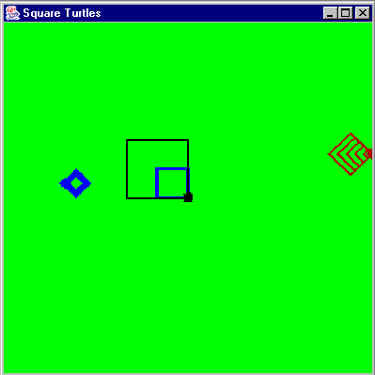
SquareTurtle left = ______________________________
SquareTurtle center = __________________________________
Turtle right = ___________________________________________
Specification
Load Filename Unit2\Lab06_7_8_9\SquareTurtle.java. Complete the class so that a SquareTurtle “knows” how to draw a square.

Load Filename Unit2\Lab06_7_8_9\Driver06.java. Create four turtles such that you use all four of the square turtle’s constructors. Draw squares of various colors, sizes, and thickness. Change one of your turtle’s sizes in the program so that one turtle ends up drawing two squares with different sizes.

Sample Run
Unit2Lab06.jar

Extensions
1. Draw the square using a for-loop.
2. Run the program with crawl turned off. What happens to the speed of the program?
Exercises
Lab06
4 import edu.fcps.Turtle;
5 public class SquareTurtle extends Turtle
6 {
7 private double mySize; //private data
8 public SquareTurtle()
9 {
10 super();
11 mySize = 50.0;
12 }
13 public SquareTurtle(double n)
14 {
15 super();
16 mySize = n;
17 }
18 public SquareTurtle(double x, double y, double h)
19 {
20 super(x, y, h);
21 mySize = 50.0;
22 }
23 public SquareTurtle(double x, double y, double h, double n)
24 {
25 super(x, y, h);
26 mySize = n;
27 }
28 public void setSize(double n)
29 {
30 mySize = n;
31 }
32 public void drawShape()
33 {
34 /************************/
35 /* Your code goes here. */
36 /************************/
37 }
38 }

- Why is line 4 important?
- What information is communicated on Line 5?
- What data does a SquareTurtle "know"?
- What happens on Line 10?
- What happens on Line 11?
- What happens on Line 20?
- Why is Line 10 different from Line 20?
- Why are there so many constructors in SquareTurtle?
- From the programmer's perspective, what must you do in the code of a constructor?
- On which lines is the code for SquareTurtle's accessor method?
- On which lines is the code for SquareTurtle's modifier method?
- Where does Turtle's abstract drawShape method become concrete?
Exercises Continued
Lab06
Equilateral triangles, 30-60-90, and 45-45-90 triangles are important special triangles. Complete the polymorphic drawShape method to draw each triangle shown below. The Java method to compute and return the square root is Math.sqrt.
- public class Equilateral extends Turtle  {  private double mySize;  // constructors, get methods, set methods  public void drawShape()  {  } | 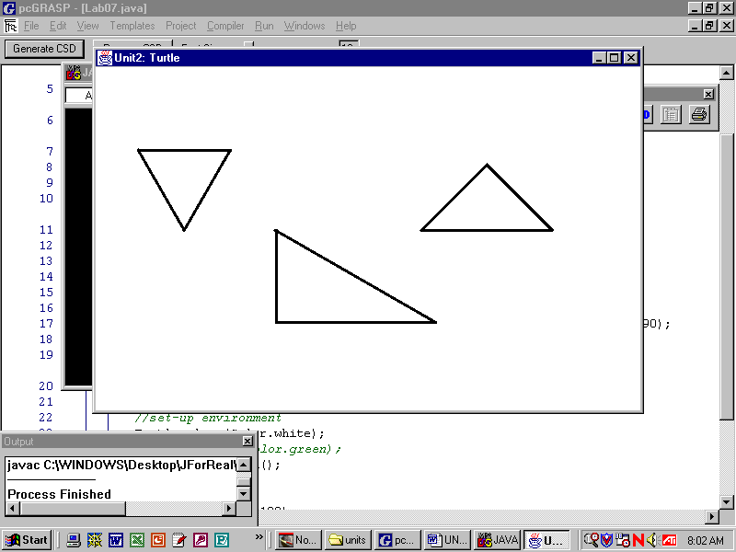  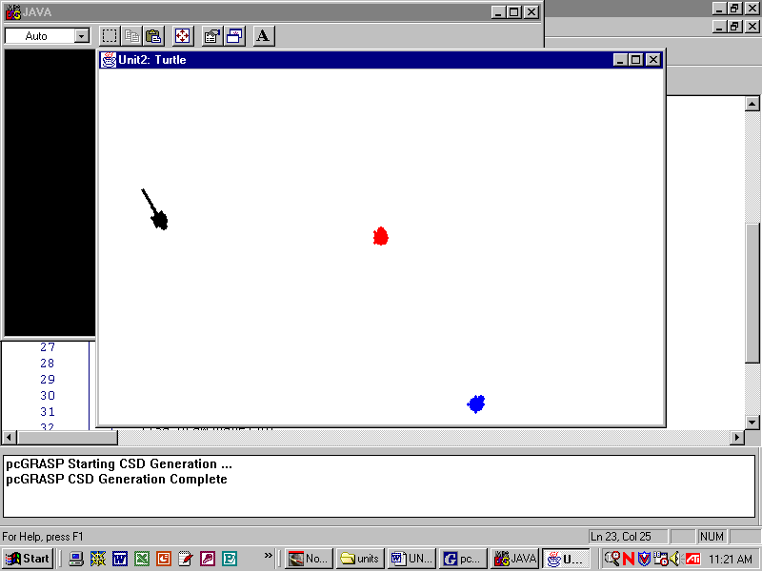
2) public class ThirtySixtyNinety extends Turtle  {  private double mySize;  // constructors, get methods, set methods  public void drawShape()  {  } | x  2x  x
3) public class IsoscelesRight extends Turtle  {  private double mySize;  // constructors, get methods, set methods  public void drawShape()  {  } | x  x  x
4) To review: a class method is marked by the ___________ keyword, has _________ copy/copies, is called using dot-notation through the ____________, and does ________ need to be instantiated to be used. An example of a class method in the Turtle labs is _______________
5) An instance method is marked by the _____________ keyword, has ________ copy/copies, is called using dot-notation through the _____________, and does _________ need to be instantiated to be used. An example of an instance method in the Turtle labs is ___________________
Lab07
Polygon Turtles
Objective
4 import edu.fcps.Turtle;
5 public class PolygonTurtle extends Turtle
6 {
7 private double mySize;
8 private int mySides;
9 public PolygonTurtle()
10 {
11 super();
12 mySize = 50.0;
13 mySides = 6;
14 }
15 public PolygonTurtle(double n, int s)
16 {
17 mySize = n;
18 mySides = s;
19 }
20 public PolygonTurtle(double x, double y,
double h, double n, int s)
21 {
22 super(x, y, h);
23 mySize = n;
24 mySides = s;
25 }
Two private fields in a turtle.

Background
The code for SquareTurtle looks much like that for PolygonTurtle.

What are the private fields in a Polygon Turtle? _______ and ________

What modifier methods will probably be in Polygon Turtle? ______and ______

On Line 11, what does super do?
________________________
(You should know that the default super does not have to be explicitly written. If it is absent, Java automatically calls the default super. Line 16 has this hidden call to the default super.)
On Lines 12 and 13, what happens to 50.0 and 6? ________________
On Lines 17 and 18, what happens to n and s? _________________
On Line 22, what happens to x, y, and h? ___________________
On Lines 23 and 24, what happens to n and s? _________________

Let's do an example. Given the code
PolygonTurtle odysseus = new PolygonTurtle(300, 0, 225, 100, 4); odysseus.drawShape();

Where does odysseus start? ___________________ What path will odysseus follow?

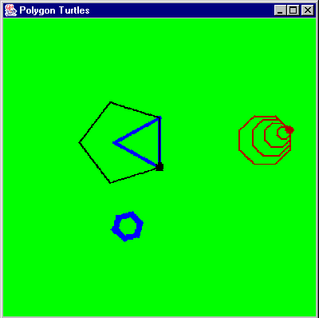
Specification
Load Unit2\Lab06_7_8_9\PolygonTurtle.java. Complete the implementation of the PolygonTurtle class. Do you remember the exterior angle theorem from geometry?

Load Unit2\Lab06_7_8_9\Driver07.java. Create different turtles using all of PolygonTurtle’s constructors. Then draw 3-, 4-, 5-, 6-, 8, and 10-sided polygons.

Sample Run
Unit2Lab07.jar
Exercises
Lab07
1) Complete Bug’s accessor method below:  public int getX()  {  } | 2) Complete Turtle’s modifier method:  private int mySize;  public void setSize (int n)  {  }
3) In Lab07, we drew different-sided polygons by changing the number of sides using setSides. It would be nicer to draw different polygons by passing an argument to drawShape. For example, drawShape(4) would draw a square and drawShape(5) would draw a pentagon. Note: Java considers drawShape() and drawShape(int s) to be different methods. Java does not get confused. We say that the drawShape method has been overloaded. Write the two methods below. The overloaded drawShape method simply sets the number of sides before it draws the polygon.
Write the original drawShape method:  public void drawShape()  { | Write the overloaded drawShape method:  public void drawShape(int s)  {
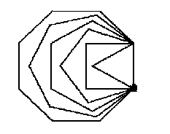
4) Write the code to produce this shape. It should use the overloaded drawShape from above. Use a for-loop to increment the number of sides.

5) Why does an object-oriented program go to all the trouble to create private data, and then create get and set methods? What advantage is there to having private data and public get and set methods?

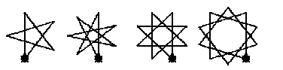
6) Star challenges: the drawShape method, with one modification, can draw stars. The same star method can draw 5-, 7-, 8- and 10-pointed stars. Can you write it?
Discussion
Access Modifiers

We have previously described private fields and public accessor and modifier methods. FlowerTurtles have two private fields:
FlowerTurtle
mySize
myColor
setColor()
setSize()
drawShape()
drawPetals()
drawStem()
public class FlowerTurtle extends Turtle
{
private double mySize;
private Color myColor;
. . .
}
In the case of FlowerTurtles, the programmer decided to write two modifier methods, but no accessor methods. The user is able to change mySize and myColor only through the public modifier methods.
The programmer also decided to make some of FlowerTurtle's methods private and some public. If a method is private, then only methods inside the class can call it. If a method is public, then classes outside the class can call it.
A FlowerTurtle’s public drawShape method draws a flower. “Drawing a flower” is broken into two parts, first the petals and then the stem. This makes the code in drawShape as simple as possible:
public void drawShape()
{
drawPetals(); //calls a private instance method
drawStem(); //calls a private instance method
}
The actual drawing of the flower is accomplished by the two private helper methods drawPetals and drawStem. The two helper methods are private because they are only used inside the FlowerTurtle object. They cannot be called from outside the FlowerTurtle object. That’s what private means.
private void drawPetals()
{
. . . //code for private instance method
}

Study this driver class:
public class Driver08
{
public static void main(String[] args)
{
FlowerTurtle lisa = new FlowerTurtle(300.0, 50.0, Color.RED);
lisa.setSize(25.0); //calls a modifier method
lisa.setColor(Color.BLUE); //calls a modifier method
lisa.drawShape(); //calls a public instance method
lisa.drawPetals(); //error—drawPetals is private!
}
}
Lab08
Flower Turtles
FlowerTurtle
mySize
myColor
setColor()
setSize()
drawShape()
drawPetals()
drawStem()

Objective

To tiptoe through the tulips.
Background
One other access issue has to do with overridden methods. Once a method has been overridden, the original superclass method cannot be invoked. Usually, this overriding is exactly what we want. Here is an example where overriding doesn't help us:
public class Driver08
{
public static void main(String[] args)
{
FlowerTurtle lisa = new FlowerTurtle(300.0, 50.0, Color.RED);
lisa.setSize(25.0); //calls lisa's setSize()
lisa.setColor(Color.BLUE); //calls lisa's setColor()
lisa.drawShape();
}
}

Lisa's setSize and drawShape work together to draw flowers of different sizes. Unfortunately, the setColor in this class does not make use of the Turtle’s setColor, which would actually set the color of lisa's pen. However, all is not lost. The superclass's setColor can be called from within the subclass class. So from inside FlowerTurtle, Turtle’s setColor can be invoked, and that setColor will make use of lisa's myColor. For example:

private void drawPetals()
{
super.setColor(myColor); //calls Turtle’s setColor, changing the color of the pen
. . .
}
This syntax is only valid from within FlowerTurtle’s definition. You cannot do super.setColor from outside the subclass of Turtle.

Specification
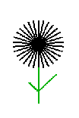
Load Filename Unit2\ Lab06_7_8_9\FlowerTurtle.java. Complete the FlowerTurtle class by implementing the drawPetals and drawStem methods. There are thirty petals in the flower shown here. The stem is one-and-a-half times as long as the petals, with leaves at forty-five degree angles. One leaf is equals the petal length, but the other leaf is half the petal length.
Load Filename Unit2\Lab06_7_8_9\Driver08.java. Draw four pretty flowers in a row, each with different color petals and green stems and leaves. Use a white background.
Sample Run
Unit2Lab08.jar
Extension
Draw a garden of randomly-placed flowers of random size. Use a loop. See Unit2Lab08ext.jar
Discussion
Polymorphic Behavior in Turtles
Any time you have a hierarchy, you have the possibility of polymorphic behavior. Here is the Turtle hierarchy. Notice that Turtle is abstract:
Turtle

TwistyTurtle
FlowerTurtle
PolygonTurtle
SquareTurtle

Here is a class method that accepts a Turtle argument:

public static void twisties(Turtle arg)
{
arg.setPenDown(false);
arg.turnRight((int)(Math.random() * 360));
arg.forward((int)(Math.random() * 200));
arg.setPenDown(true);
arg.drawShape();
}

Draw the possible output for each driver method:

public static void main(String[] args)
{
Turtle smidge = new SquareTurtle();
twisties(smidge);
}

public static void main(String[] args)

{
Turtle smidge = new PolygonTurtle();
twisties(smidge);
}

public static void main(String[] args)

{
Turtle smidge = new FlowerTurtle();
twisties(smidge);
}

Clearly, we have a superclass reference to a subclass object. Which code, the reference's or the object's, is executed by arg.drawShape?
some Turtle
OBJECT
smidge
arg
some Turtle
OBJECT
smidge
arg

How is twisties an example of polymorphism?

Lab09
Twisty Turtles
Objective
To draw twisty designs.
Background
A TwistyTurtle is a subclass of Turtle. A TwistyTurtle does not store any private data. A TwistyTurtle has only a default constructor, which you don’t even have to write, because Java generates one for you (under certain conditions). A TwistyTurtle implements only one method, drawShape, which has one loop. The loop specifies the beginning length of the line, the end length, and the increment. Each twisty specifies its own turning angle, line thickness, and line color.
 | 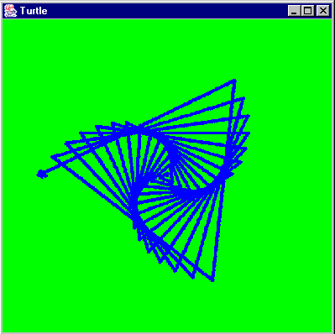  TwistyTurtle | 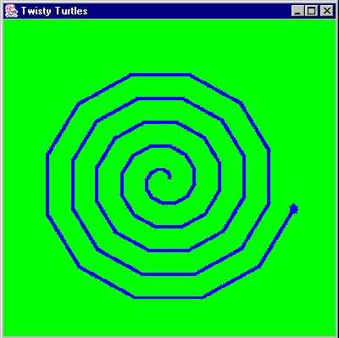  TwistyTurtle2 | 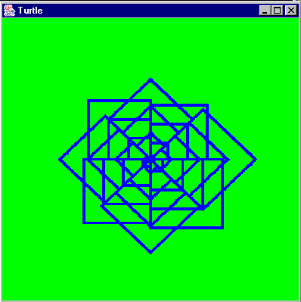  TwistyTurtle3
begin length | 5 | 0 | 25
end length | 400 | 150 | 150
increment | 10 | 2 | 5
angle | 123 | 30 | rotate a square by 45

Experiment with your own values for the length of the side, the increment, and the angle.

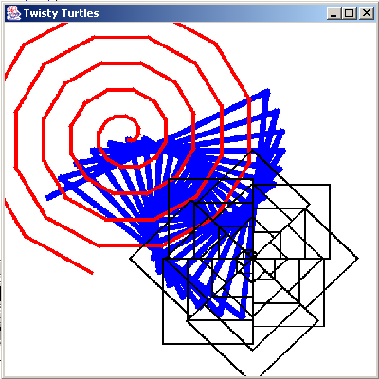
Specification
Create Unit2\Lab06_7_8_9\TwistyTurtle.java, TwistyTurtle2.java, and TwistyTurtle3.java. Make three different TwistyTurtles, each implementing a different twisty design in drawShape.
Create Unit2\Lab06_7_8_9\Driver09.java. Draw all three twisties on the same screen. Use the class method twisties which is given on the previous page.
Sample Run
Unit2Lab09.jar
Extension:
Using the class method twisties, draw a square, an octagon, a flower, and a twisty. Explain how this is an example of polymorphism.

Extension 2:
Have your original TwistyTurtle class implement the Runnable interface (Unit1, Lab14). All run will do is call drawShape. In your driver create three twisty turtle objects each with their own thread. Start the threads and watch your turtles twist in parallel. See Unit2Lab09ext.jar
Exercises
Writing Your Own Class
Step 1
Choose a class from the list below. Circle it.

Dog House Car City Book Boy
Hat Child Ring School Family Girl
Cat Song Cookie Flower Bird ____________

Step 2
Circle the appropriate abstract superclass from the list below:

Animal Vegetable Mineral Idea ________________

Step 3 Step 4
Design the class. What should your class know? What should your class do? Include at least 1 private field, 2 constructors (one must be the default constructor), and accessors and modifiers (set methods and get methods) for each private field. Design at least 1 appropriate instance method.

Extra credit: Include a class method.

The class outline below may help you. Looking at the code for Bug and SquareTurtle might help you with syntax.

Write the resource class.

public class ___________ extends _____________
{

name:

(class method:)

fields:

constructors
default:

with arguments:

accessors:

modifiers:

instance method(s):

Step 5 – Turn this page in to the teacher.
Exercises, continued
Writing Your Own Class
Step 6
Exchange your resource class with another student. Write a driver class (a client class) that uses the other student's resource class. Instantiate two objects using the two constructors. Call at least one set (modifier) method. Call the instance method (and the extra credit class method, if they wrote one.) Using the get (accessor) methods, output the information (System.out.println()) stored in each object, with appropriate labels.

public class __________
{
public static void main (String [] args)
{

Lab10
Polka Dots
Objective
To set up a bufferedImage (see Lab03) and a timer. The Polkadot class.
4 import javax.swing.*;
5 import java.awt.*;
6 import java.awt.event.*;
7 import java.awt.image.*;
8 public class PolkaDotPanel extends JPanel
9 {
10 //constants
11 private static final int FRAME = 400;
12 private static final Color BACKGROUND = new Color(204, 204, 204);
13 //fields
14 private BufferedImage myImage;
15 private Graphics myBuffer;
16 private Timer t;
17 private Polkadot pd;
18 private int xPos, yPos;
19 public PolkaDotPanel()
20 {
21 myImage = new BufferedImage(FRAME, FRAME, BufferedImage.TYPE_INT_RGB);
22 myBuffer = myImage.getGraphics();
23 myBuffer.setColor(BACKGROUND);
24 myBuffer.fillRect(0, 0, FRAME, FRAME);
25 pd = new Polkadot();
26 t = new Timer(1000, new Listener());
27 t.start();
28 }
29 public void paintComponent(Graphics g)
30 {
31 g.drawImage(myImage, 0, 0, getWidth(), getHeight(), null);
32 }
33 private class Listener implements ActionListener
34 {
35 public void actionPerformed(ActionEvent e)
36 {
37 /**************************
38 your code goes here
39 **************************/
40 pd.jump(FRAME, FRAME);
41 pd.draw(myBuffer);
42 repaint();
43 }
44 }
45 }
Background
Lines 4-7: we need to import many packages.
This class "isa" JPanel.
Lines 11 & 12: two private constants, both static and final. Why?
Lines 14-18: six private fields. Line 17 says we will be using a Polkadot object. What is that?! At this point, we don’t need to know!
Lines 19-28: the constructor instantiates objects. It only runs once. As with Turtles, we use an off-screen buffer, paintComponent, a Timer, and a Listener to produce motion. The Timer has a loop that calls the Listener every 1000 ms.
All the animation happens in the Listener (lines 33-43). In this code, the pd jumps and draws itself. repaint on Line 42 actually pastes the updated bufferedImage on the Graphics panel. You need call repaint only once at the end of the method.

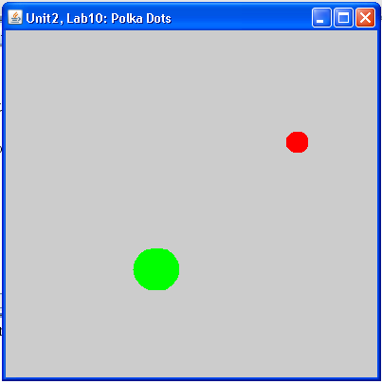
Specification
Load Unit2\Lab10\PolkaDotPanel.java. Study the code above!
Load Unit2\Lab10\PolkaDot.java. Complete this resource class; see the next page.
Load Filename Unit2\Lab10\Driver10.java. Compile and run. You will see that polkadots keep appearing, one every second. First, add some code at lines 37-39 in PolkadotPanel so only one polkadot appears to jump around the screen. After that works, make two polkadots of different sizes and colors jump around the screen.

Warning: A common error is to write Line 25 as Polkadot pd= new Polkadot(); Write Line 25 that way. Then explain what the error message null pointer exception means.

Sample Run Unit2Lab10.jar
Discussion
5 import java.awt.*;
6 public class Polkadot
7 {
8 private double myX; // x coordinate of center
9 private double myY; // y coordinate of center
10 private double myDiameter;
11 private Color myColor;
12 private double myRadius;
14 public Polkadot()
15 {
16 myX = 200;
17 myY = 200;
18 myDiameter = 25;
19 myColor = Color.RED;
20 myRadius = myDiameter/2;
21 }
22 public Polkadot(double x, double y,
double d, Color c)
23 {
24 myX = _x_;
25 myY = _y_;
26 myDiameter = _d_;
27 myColor = _c_;
28 myRadius = _d/2_;
29 }
31 public double getX()
32 {
33 return myX;
34 }
35 public double getY()
36 {
37 __ return myY;__
38 }
39 public double getDiameter()
40 {
41 ___return myDiameter;___
42 }
43 public Color getColor()
44 {
45 return myColor;
46 }
47 public double getRadius()
48 {
49 return myRadius;
50 }
52 public void setX(double x)
53 {
54 myX = x;
55 }
56 public void setY(_double y_)
57 {
58 __myY = y;__
59 }
60 public void setColor(Color c)
61 {
62 myColor = c;
63 }
64 public void setDiameter(double d)
65 {
66 myDiameter = d;
67 myRadius = d/2;
68 }
69 public void setRadius(double r)
70 {
71 __myRadius = r;__
72 __myDiameter = 2*r;___
73 }
75 public void jump(int rightEdge,int bottomEdge)
76 { //code
80 }
81 public void draw(Graphics myBuffer)
85 { // a polkadot draws itself from its center
86
Polkadot
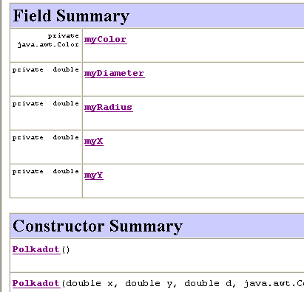
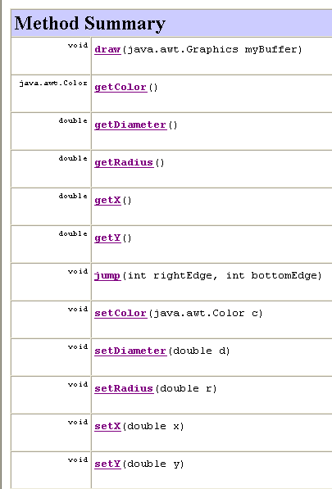
What can a polkadot do? What do they know? The API below is generated from the code at the right.
Discussion
Ball
What should a ball “know”—i.e., what fields? What should a ball be able to do—i.e., what methods? Can a Ball make use of fields and methods in Polkadot?
2 import java.awt.*;
3 public class Ball extends Polkadot
4 {
5 private double dx;
6 private double dy;
7 // constructors
8 public Ball() //default constructor
9 {
10 super(200, 200, 50, Color.BLACK);
11 dx = Math.random() * 12 - 6; // horizontal
12 dy = Math.random() * 12 - 6; // vertical
13 }
14 public Ball(double x, double y, double dia, Color c)
15 {
16 super(x, y, dia, c);
17 dx = Math.random() * 12 - 6;
18 dy = Math.random() * 12 - 6;
19 }
20 //modifier methods
21 public void setdx(double x)
22 {
23 dx = x;
24 }
25 public void setdy(double y)
26 {
27 dy = y;
28 }
30 //accessor methods
31 public double getdx()
32 {
33 return dx;
34 }
35 public double getdy()
36 {
37 return dy;
38 }
40 //instance methods
41 public void move(double rightEdge, double bottomEdge)
42 {
43 _____________________
. . .
50 }

For its fields, a ball needs to know at least its location, diameter, and color. In fact, there were five private fields in Polkadot.
1. What were they?
__myX__ __myY___ _ myDiameter_
_ myColor_ _ myRadius_
Because they share so much,
it seems reasonable to make
Polkadot

Ball extend Polkadot, as
shown in this UML diagram.
Ball

In Java, Ball inherits the public methods, but not the private fields, from Polkadot. Ball cannot directly access myX and myY, or any of the other private fields. But the programmer was thinking ahead, because she wrote public accessor and modifier methods for all of Polkadot’s private fields. When Ball needs to access those fields, the Ball class must use the public getX and setX methods.

2. As you know, a Ball inherits all public instance methods from Polkadot. What do Balls know how to do, because Polkadots know how to do them? ______ _______
Ball 繼承 Polkadot 的所有 public 方法，例如getX, setX, getY, setY, getColor, setColor, draw
3. The programmer gave Ball two new fields on Lines 5 and 6. What are the new fields in Ball? dx, dy ______
Because these fields are in Ball, the Ball class can access them directly. But we also write public accessor and modifier methods for them, in case we later extend the Ball class.

4. What do you think these new fields do? dx 和 dy 表示 Ball 每次移動時的水平與垂直速度（變化量）
5. On what lines are the constructors?
public Ball() //default constructor // line 8
public Ball(double x, double y, double dia, Color c) // line 14
6. What does the keyword super do?
super(...) 是呼叫父類別（Polkadot）的建構子，傳入 x、y、直徑、顏色等欄位。
7. What are the attributes of the default Ball object?
Line 10 ~ 12
8. The author also gave Ball one new public method move. In words, describe what has to happen to make the ball appear to move slowly horizontally.
要讓球看起來慢慢向右移動，可以讓 x 值每次加上一個小的 dx 值（例如 dx = 1）。
9. On Line 43 in the code above, write one line that causes this ball object to move dx spaces horizontally.
setX(getX() + dx);
Lab11
Bouncing Pinball
Objective
The Ball class and motion.
Background
Here is the actionPerformed method of the PinballPanel. Just as in the Polkadot lab, the buffer is painted gray and then a new image is repainted. If the ball moves a little bit, and the timer fires quickly, the ball appears to roll around the screen. Notice we have encapsulated both the movement and the painting in the Ball class, i.e., ball objects "know" how to move and to paint themselves.
35 private class Listener implements ActionListener
36 {
37 public void actionPerformed(ActionEvent e)
38 {
39 myBuffer.setColor(BACKGROUND);
40 myBuffer.fillRect(0,0,FRAME,FRAME);
41 ball.move(FRAME,FRAME);
42 ball.draw(myBuffer);
43 repaint();
44 }
45 }
46 }
2 import java.awt.*;
3 public class Ball extends Polkadot
4 {
5 private double dx;
6 private double dy;
. . .
41 //instance methods
42 public void move(double rightEdge, double bottomEdge)
43 {
44 setX(getX()+ dx); //move horizontally
45
46 if(getX() >= rightEdge - getRadius()) //hit right edge
47 {
48 setX(rightEdge - getRadius());
49 dx = dx * -1;
50 }
51 /* more code goes here */
52
53
54
55
What is a Ball? It makes sense that a Ball should inherit many items that are already in Polkadot. (Like what?) What's new in Ball is the dx and dy, for delta-x and delta-y, meaning the change in x and the change in y. The Ball class chooses both of these values as random numbers. What if the dx is 0? What if the dy is 0? What if both are 0?

Lines 7-40: of course, the Ball class has its own constructors, accessors, and modifiers.

How can we make a ball move horizontally? Get the ball's x-position, add the delta-x, and make it the new x-position. The code for this is on Line 44.
dy
dy
dx
How does the ball know when it hits the right edge? It continually checks to see if its x-position is too large. One trouble is that the ball knows the coordinates of its center, but it bounces off the edge when the ball's radius hits the edge. The code in Line 46 accounts for that. What does it mean to bounce, that is, how do the dx and dy change when a ball hits the right edge? How many edges do you have? What does it mean, in terms of dx and dy, to bounce off each edge?
Specification
Copy Unit2\Lab10\Polkadot. Since you don't instantiate a polkadot, why do you have to copy it?
Load Filename Unit2\Lab11\Ball.java. The ball moves sideways and bounces off the right edge (don't change it!). Use that code as a model to make the Ball move in all directions and bounce off all edges.
Load Filename Unit2\Lab11\PinballPanel.java.
Create Filename Unit2\Lab11\Driver11.java. Create an appropriate driver.

Sample Run Unit2Lab11.jar

Extension Make a new class extending Ball that draws the tj.jpg image from Lab02. The image will bounce! Note that TJ has code for exactly one (1) overridden method: public class TJ extends Ball
{ public void draw(Graphics myBuffer)
Exercises
Labs10 and 11
Answer the questions about these five (very simplified and rudimentary) classes. A {…} in the code below indicates that code has been omitted.
public class P
{
private int myX;
public P(int x)
{
myX = x;
}
public int getX()
{…}
public void drawMe()
{…}
}

public class B extends P
{
private double dx;
public B()
{
super(100);
dx = 5;
}
public double getdx()
{…}
}

public class T extends B
{
public void drawMe()
{…}
}

- Circle the true statements:
public class D
{
private final int xx=10;
public static void drawAll()
{
P p = new P(10);
B b = new B();
T t = new T();

p.drawMe();
b.drawMe();
t.drawMe();

}
public static void main(String[] args)
{
drawAll();
}
}
B isa P P isa B A isa P
T isa B T isa P A hasa P
- Can P directly access myX? Y/N
- Can B directly access myX? Y/N, private in P
- Can A directly access myX? Y/N, doesn’t exit
- If P needs to access myX, it can use _myX or this.myX_
- If B needs to access myX, it must use _getX()_
- If T needs to access myX, it must use _getX()_
- Can P directly access dx? Y/N, dx is in B
- Can B directly access dx? Y/N
- Can T directly access dx? Y/N, private in B
- If T needs to access dx, it must use _getdx()_
- Can A directly access xx? Y/N
- Can T directly access xx? Y/N, private in D
- Can D directly access p, b, or t? Y/N
- Can xx be changed? Y/N, it’s final
- Why doesn't P have an explicit super? _因為 Java 的所有類別預設繼承自 Object 類別，不需要寫 super()。_
- Why does B have an explicit super? _因為 P 的建構子需要一個整數參數，所以 B 必須用 super(100) 呼叫它。_
- Why doesn't T have a constructor? ___它會自動使用從 B 繼承來的建構子。___
- Why does B have dx=5 ? __因為要設定移動的速度或方向__
- Does B have a drawMe? Y/N Explain: _B 沒有定義 drawMe()，但它會繼承 P 的 drawMe() 方法。_
- Why does T have its own code for drawMe? __因為它想畫出不同的東西。__
- What word describes the relationship between P's drawMe and T's drawMe? __覆寫（Override）_
- Class D has a field xx that is final What does final mean? __一旦賦值後就不能被改變。__
- Class D has a static method drawAll. Why does static mean? (3 things)
屬於「類別」而不是物件、不需要創建物件就可以使用、不能直接使用非 static 的變數或方法。
- D is a __驅動類別（Driver class）__. In D, write code that instantiates each object (P with a size of 10, B with its default size, and T with its default size) and tell each object to draw itself.
Lab12
Get the Prize
Objective
Using multiple classes with appropriate responsibilities.
Background
Object-oriented programming attempts to distribute appropriate responsibilities to the different classes. Polkadots should do polkadot stuff, balls should do ball stuff, and panels should organize them. In this lab, panel's responsibility is also to decide when the moving ball actually hits the polkadot, to count those times, and to display the count. That is, PrizePanel eventually will have an additional private field to store the number of hits, a private method called collide and a private method called distance.
36 private class Listener implements ActionListener
37 {
38 public void actionPerformed(ActionEvent e)
39 {
40 myBuffer.setColor(BACKGROUND);
41 myBuffer.fillRect(0,0,FRAME,FRAME);
42
43 ball.move(FRAME, FRAME);
44 collide(ball, pd);
45
46 ball.draw(myBuffer);
47 pd.draw(myBuffer);
48
49 myBuffer.setColor(Color.BLACK);
50 myBuffer.setFont(new Font("Monospaced", Font.BOLD, 24));
51 myBuffer.drawString("Count: " + hits, FRAME - 150, 25);
52 repaint();
53 }
54 }
55 private void collide(Ball b, Polkadot pd)
56 {
57 double d = distance( /* 4 arguments */ );
58 if( d <=
59
60
Study the panel's Listener.
Line 43: the ball moves itself
Line 44: the panel calls its private collide method, passing the ball and the polkadot.
Lines 55-60: The collide method then calculates the distance and if the ball hits the polkadot, the hit counter goes up by one and the polkadot jumps to a new location.
Lines 46-51: the ball draws itself, the polkadot draws itself, and the "Count: 1" string is drawn in the upper-right hand corner of the panel.
x1, y1
x2, y2
Line 58: How do they know they collide? The ball and the polkadot each "know" their own position. If the distance between their centers (recall the distance formula from algebra) is less than the sum of their respective radii, then they hit.
The distance formula uses both Math.sqrt and Math.pow, which return doubles. The expression to square the difference between x2 and x1 is Math.pow(x2 – x1, 2);
Specification
Copy Polkadot.java and Ball.java from Lab11.
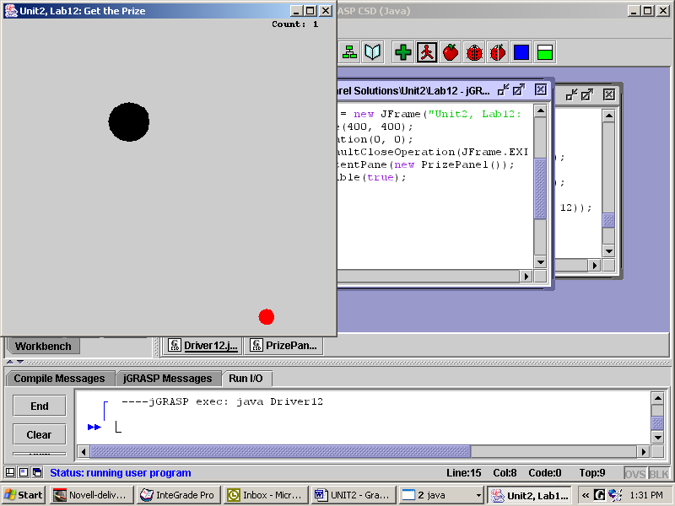
Load Filename Unit2\Lab12\PrizePanel.java. The panel’s fields are given to you. Using PinballPanel as a model, complete the constructor and paintComponent. Type in the actionPerformed method given above. Complete collide and distance. Then modify PrizePanel to count and report the number of times the ball hits the polkadot.
Filename Unit2\Lab12\Driver12.java. Create an appropriate driver.
Sample Run
Unit2Lab12.jar

Lab13--Project
Riddle Me This
Objective
To make your teacher and classmates laugh.
Background
Ever since Lab03, we have pretended that myImage's image was a Graphics type object. In truth, Graphics is abstract, so the actual object created is a subclass of Graphics. Then when the Java programmers decided to add more powers to the Graphics class, they chose to extend it. They named the new class Graphics2D, and also kept it abstract. Look at the API for Graphics2D.
Graphics2D inherits familiar Graphics methods like fillRect, drawPolyline, setColor, and setFont. It overrides and overloads the method drawString. Graphics2D helpfully defines a new method setStroke. The method setStroke and a BasicStroke object, whose constructor takes a float (not a double) decimal number as an argument, can be used to change the thickness of lines. Here is an example:
myBuffer.setStroke(new BasicStroke(10.0f)); //10 pixels wide
Graphics
Graphics2D

So far, so good. However, the method myImage.getGraphics returns a Graphics reference, because the original Graphics class was written that way. The question is, how do we make the brand-new and better Graphics2D commands available? We can't, unless we cast the getGraphics return reference to its subclass type. The new reference becomes "bigger" because it points to the subclass with all its methods, including the new ones. We uncover the Graphics2D object that we know are there, but getGraphics does not. The cast occurs in line 19, inside the parentheses. myBuffer now accesses Graphics2D commands.
some concrete class

Clearly we are using the same structure that we used in Lab10 and Lab11. What's new is being able to use setStroke.
8 public class ProjectPanel extends JPanel
9 {
10 private static final ImageIcon THOMAS =
new ImageIcon("tj.jpg");
11 private BufferedImage myImage;
12 private Graphics2D myBuffer;
13 private Timer t1, t2;
14 private int xPos;
15 public ProjectPanel()
16 {
17 xPos = 50;
18 myImage = new BufferedImage(700, 500,
BufferedImage.TYPE_INT_RGB);
19 myBuffer = (Graphics2D)myImage.getGraphics();
20 t1 = new Timer(100, new Listener1());
. . .
25
}

Specification
Open RiddlePanel.java. Ask, answer, and illustrate a riddle. Use at least one ImageIcon image (refer to Lab02), various polygons, at least two different pen-widths, text output, two timers, and two listeners. One timer and its listener moves an image across the screen. The second timer waits a while, then reveals the answer to the riddle.
Open Unit2\Lab13\RiddleDriver.java. Compile and run.
Sample Run Unit2Lab13.jar
Lab14
Prize with Bumper
Objective
Designing a class from scratch (mostly).
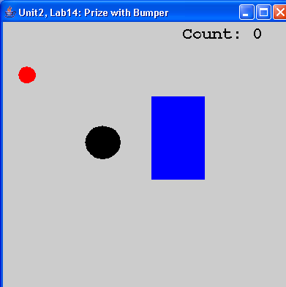
Background
The panel is just like Lab12, with a moving ball, a jumping prize, and a counter, but has a rectangular bumper somewhere in the middle of the screen. The bumper is (of course) an object of the Bumper class. The author had to ask him/herself a series of questions, including:

1. Is there a suitable class that Bumper could extend?

2. What private data should a bumper know about itself?

3. What constructors would be nice to have?

4. What get and set methods are needed?

5. What instance methods are needed? That is, what should a bumper know how to do?

#1: The author thought about extending Polkadot because both have x and y coordinates. However, since Bumper does not have a diameter or a radius, it seemed better not to have Bumper extend anything.

#2: Bumpers at a minimum need to know their upper left hand corner, their width, and their height, because that is how they are drawn. It might be nice to have different colored bumpers.

#3: The default constructor always places the bumper in the same place. It would be nice to place it in different places with different sizes. Let’s make two constructors, a no-arg and a 5-arg constructor.

#4: Get-methods are needed to get the x, y, width, and height. Set-methods might not be needed, unless the position, size, and color of the bumper need to be changed. If we make Pong, for instance, we will need setY.

#5: A bumper should know how to draw itself, like Polkadot and Ball. If a bumper knew how to jump to a random location, the game would change each time we ran it.

Somewhere, we must define how the ball bounces off the bumper. Bouncing off the corners of the bumper involves “vector algebra.” Luckily for you, the author already wrote and encapsulated all that code in a separate class. BumperCollision.collide(bumper, ball) is the syntax for calling that magic method.

Specification
Copy Polkadot.java, Ball.java, and Driver12.java from Lab12.

Load Filename Unit2\Lab14\Bumper.java. Complete the design of the class. Create 5 fields, 5 accessor methods, 5 modifier methods, and 2 constructors. You have 1 instance method to complete. See the next page.

Load Filename Unit2\Lab14\BumperPanel.java. Instantiate all three objects, than jump them to random locations.

Sample Run
Unit2Lab14.jar
Lab14
5 public class Bumper
6 {
7 //private fields
8
9
10
11
12
13
14
15 //constructors
16 public Bumper()
17 {
18
19
20
21
22
23 }
24 public Bumper(int x, int y,
int w, int h, Color c)
25 {
26
27
28
29
30
31 }
32 // accessor methods
33
34
35
36
37
38
39
40
41
42
43
44
45
46
47 // modifier methods
48
49
50
51
52
53
54
55
. . .
76
77
78 //instance methods
79 public void jump(int rightEdge, int
bottomEdge)
Exercises
Study the API below. Write the code for Bumper. Your code must conform to the specifications below. For example, the fields in Bumper are all ints. You must spell “Height” correctly. The inBumper method tests to see if the polkadot is inside the bumper or not. The inBumper method uses the private distance method which you saw in Lab12.
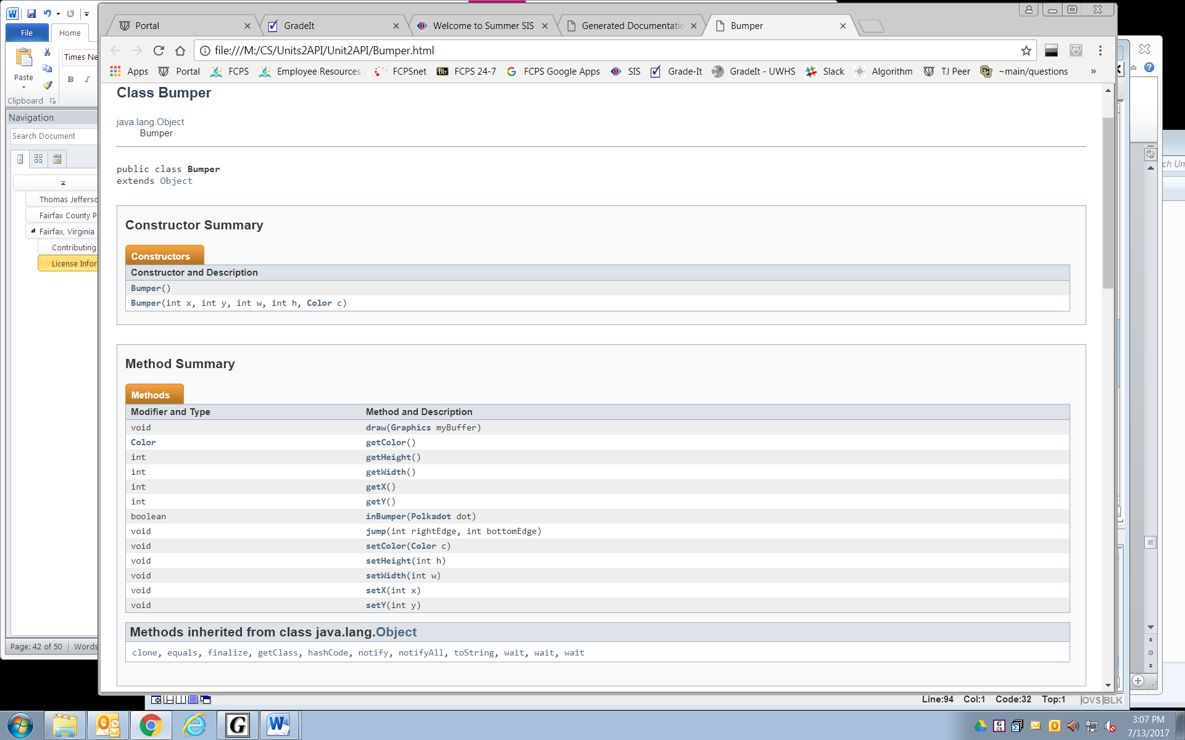
Lab15
Karel the Robot
Objective
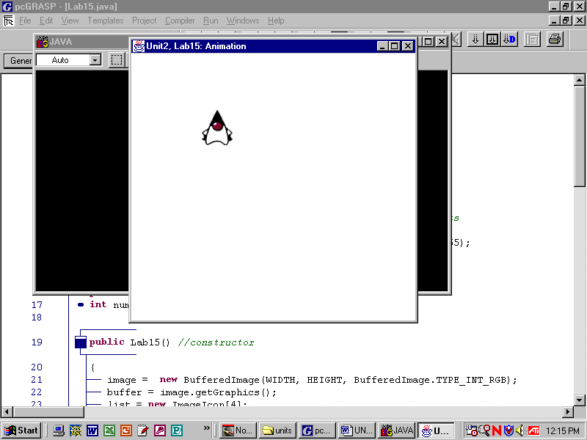
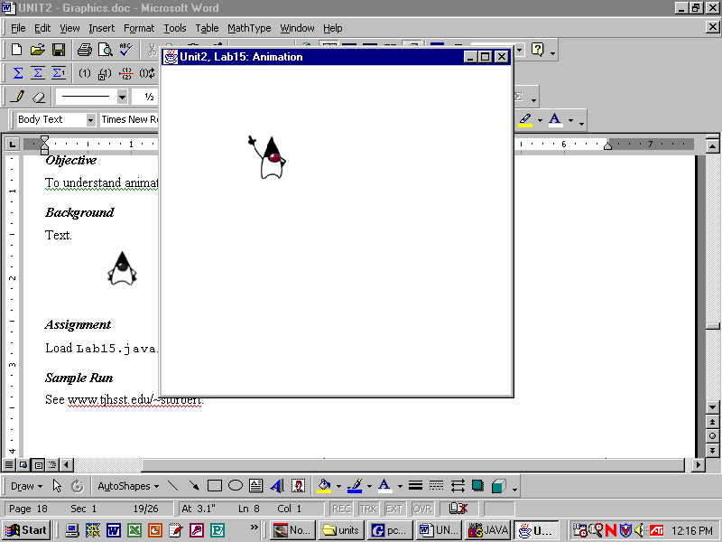
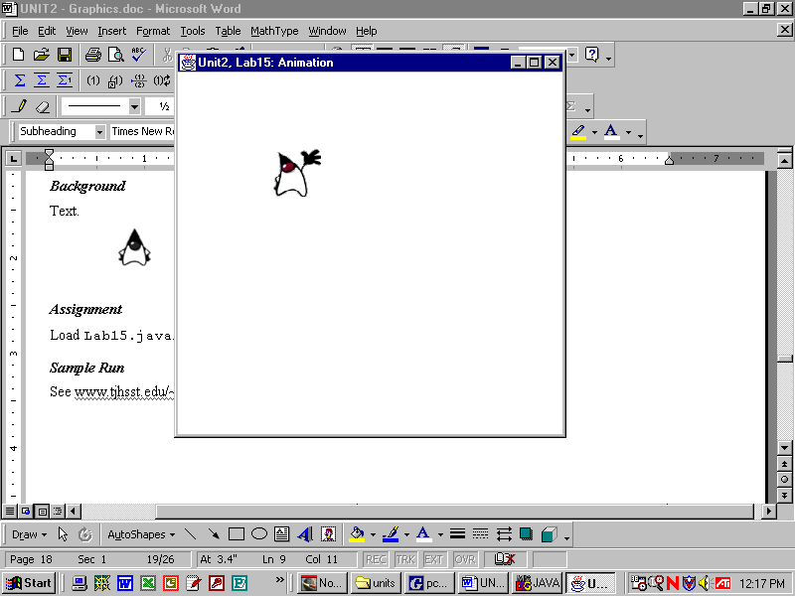
To simulate an animated gif.
array
[0]
[1]
[2]
[3]
Background
We accomplished the appearance of moving balls by quickly erasing a picture and drawing it again in a slightly new position. The same appearance of motion can be accomplished by cycling through a series of images stored in an array, if the images are chosen carefully. (This is the way animated gifs and sprites work.)
As the values of the array's index cycles from 0 to 1 to 2 to 3 to 0 to 1 and so on, the image that actually gets displayed keeps changing. Each image is just a still shot but the cycling of images gives the appearance of motion.
This lab will use karel the robot images stored in an array. Karel can face either east, north, west, or south. Your code will have to select which image is appropriate. The first, basic assignment is to make the robot move around the edges of the grid.

[0] | [1] | [2] | [3]

array
As with all images, the (xPos, yPos) coordinates of the images refer to the upper-left hand corner. Unfortunately, the karel images are not square. That makes proper spacing a bit tricky in this lab. To get the width and height of the image stored in myArray[0] use the commands:
int width = myArray[0].getImage().getWidth(null);
int height = myArray[0].getImage().getHeight(null);
To actually display the image stored in myArray[0] use the command (last seen in Lab02):
myBuffer.drawImage(myArray[0].getImage(), xPos, yPos, null);
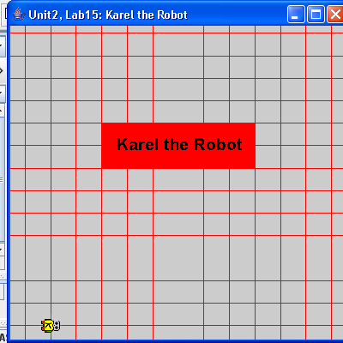
Specification
Load Filename Unit2\Lab15\KarelPanel.java. You will have to draw the gridlines. Make Karel travel around the grid, turning so its head is always pointing forward. Then make Karel do a dance.

Load Filename Unit2\Lab15\Driver15.java.
Sample Run
Unit2Lab15.jar

Lab16
Mouse Input
Objective
To modify the “Get the Prize” lab (Lab 12) to include mouse input.

Background
Not all listeners are ActionListeners registered with Timers. You can also register a MouseListener with the JPanel itself, as shown on Line 30.
16 public PrizePanel()
17 {
. . .
30 addMouseListener(new Mouse());
31 t = new Timer(10, new Listener());
32 t.start();
33 }
. . .
37 private class Mouse extends MouseAdapter
38 {
39 public void mousePressed( MouseEvent e )
40 {
41 ball.setX( e.getX() );
42 ball.setY( e.getY() );
43 }
44 }

The Listener object on Line 31 is the same Listener from Lab12, which implements the ActionListener interface, which controls the motion of the objects.

On line 37, the Mouse class could either implement the MouseListener interface or extend the MouseAdapter class. If you implement MouseListener you’ll need to define five methods, even if you only use one of them. To avoid this complication, the MouseAdapter class provides default (empty) definitions for these methods, so only the methods that you override need to be defined.

Notice the mysterious e.getX() method. It looks like it could be a standard accessor method on the e object. This object e is instantiated somewhere up in the MouseAdapter hierarchy. Whenever you click, this e object is automatically passed to the mousePressed method. The e object has its own set of methods. It turns out that e.getX() returns the x location of the mouse pointer, and similarly for e.getY(). Study Lines 41 and 42, which move the ball to the spot where you clicked.

Specification
Copy all files from Lab12. Set the JFrame's size to (408, 438), which makes the mouse's location in the JFrame correspond to its location in the JPanel. Then modify the mousePressed method to get three different behaviors from e:
button | boolean method | desired behaviors
left click | <none> | moves the polkadot to where you clicked
right click | e.isMetaDown() | moves the ball to where you clicked
Shift + left click | e.isShiftDown() | randomly changes the speed and direction of the ball

Sample Run
Unit2Lab16.jar

Extension
Implement an interesting behavior that is allowed by the MouseMotionListener interface. MouseMotionListener objects are registered with the addMouseMotionListener method.
Lab17
Keyboard Input
Objective
To modify the “Get the Prize” lab (Lab 12) to include keyboard input.
4 //imports
. . .
9 public class PrizePanel extends JPanel
10 {
. . . //fields
16 public PrizePanel() //constructor
17 {
. . .
30 addKeyListener(new Key());
31 setFocusable(true);
. . .
44 }
45 //private listener classes
. . .
60 private class Key extends KeyAdapter
61 {
62 public void keyPressed(KeyEvent e)
63 {
64 if(e.getKeyCode() == KeyEvent.VK_W)
65 ball.setY( ball.getY()-1 );
66 if(e.getKeyCode() == KeyEvent.VK_Z)
67 ball.setY( ball.getY()+1 );
68 if(e.getKeyCode() == KeyEvent.VK_A)
69 ball.setX( ball.getX()-1 );
70 if(e.getKeyCode() == KeyEvent.VK_S)
71 ball.setX( ball.getX()+1 );
72 }
73 }
74 //public instance methods
. . .
150 }

Background
Still another Listener is a KeyListener, which can be registered with any JPanel. Look at Line 30 for an example.
Now each application can have three listeners, one each for the mouse, the keyboard, and the timer.
The private Key class on Line 60 could either implement the KeyListener interface or extend the KeyAdapter class. If you implement KeyListener you’ll need to define three methods, even if you only use one of them. On the other hand, the KeyAdapter class provides default (empty) definitions for these methods, so only the methods that you actually use need to be defined.

Notice that Lines 64, 66, 68, and 70 call accessor methods of a mysterious KeyEvent object named e, so that e.getKeyCode() returns the key that was pressed. VK_W, etc., are constants in the KeyEvent class. The result is that Lines 64 to 71 move the ball either 1 pixel up, down, left, or right.

Specification
Copy all the resource files from Lab16. Use the code above as a model so that the arrow keys move the polkadot ten pixels at a time. Do not allow the keys to move the polkadot outside the boundaries of the panel.
Load Filename Unit2\Lab17\Driver17.java. Notice that the driver calls the panel's method requestFocus. Alternatively, you can change the focus by clicking on the panel, which makes the keys work on that panel.
Sample Run
Unit2Lab17.jar

Extensions
1) Make a new folder for Pong. Copy into it all needed files from Lab14. Modify BumperPanel so that the keys move the bumper vertically.
2) Make a two-person Pong game. Keep score.
3) In Lab15, modify KarelPanel to use both mouse and keyboard input.
4) A website that students have found helpful is http://www.faqs.org/docs/javap/index.html
Discussion
Turtle, from scratch
The shell shown below begins to code the Turtle class described in Lab06, but without a Turtle image or animation. Why are the img and the colors all static fields? Why are x, y, and theta not static fields?
import java.awt.*;
import java.awt.image.*;
public class Turtle
{
private static BufferedImage img;
private static int black = 0;
private static int blue = 255; // 2^8-1
private static int green = 65280; //(2^8-1)*2^8
private static int red = 16711680; //(2^8-1)*2^16
private static int white = 16777215; // 2^24-1
private double x, y, theta; // what does a Turtle know?
static // a static initializer list
{
img = new BufferedImage(800, 600, BufferedImage.TYPE_INT_RGB);
}
public Turtle()
{
x = img.getWidth()/2; //start at the center
y = img.getHeight()/2; //start at the center
theta = 90; //90 degrees faces north
}
public static Image getImage()
{
return img;
}
public void turnLeft(double a)
{
theta += a;
}
public void forward(double r)
{
// Your code goes here!
}
}
You’ll need to complete the method forward by calculating each pixel on the path and setting it to white. For instance, to set one pixel at location (x, y) of img to black, the command is:

r
img.setRGB( (int)x, (int)y, black );
x, y
You'll need a for-loop, obviously. You might find the trig concepts from Lab03 to be useful. Recall that Java works in radians. If you try to set a pixel that is outside the area of image, you will get an error message.
Add more constructors and methods to your Turtle class. Some possible methods to add are turnRight, back, penDown, setColor, and clear.
Lab18
Turtle, from scratch
Objective
To solve a problem by first writing a resource class.
Background
import java.awt.*;
import javax.swing.*;
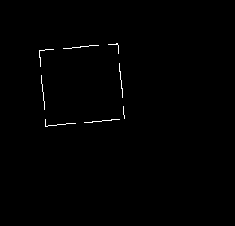
public class Lab18 extends JPanel
{
public static void main(String[] args)
{
Turtle t = new Turtle();
t.turnLeft(5);
for(int k=0; k<4; k++)
{
t.forward(100);
t.turnLeft(90);
}

JFrame f = new JFrame();
f.setSize(800,600);
f.setDefaultCloseOperation(JFrame.EXIT_ON_CLOSE);
f.setContentPane(new Lab18());
f.setVisible(true);
}
public void paintComponent(Graphics g)
{
g.drawImage(Turtle.getImage(),0,0,getWidth(),getHeight(),null);
}
}

Specification
Open Unit2\Lab18\Turtle.java. Finish the Turtle class from the previous page.
Create Unit2\Lab18\Driver18.java. Use the driver shown above to draw a tilted square. Then modify the driver to draw a more interesting picture with your built-from-scratch turtles.
Sample Run
Unit2Lab18.jar
Exercises
Lab18
Write the methods drawLine, drawCircle, and drawOval using only the BufferedImage method setRGB.
public void drawLine(BufferedImage img, int x1, int y1, int x2, int y2)
{

}

public void drawCircle(BufferedImage img, int x, int y, int r)
{
Midpoint Circle Algorithm
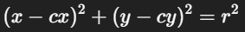

}

public void drawOval(BufferedImage img, int x, int y, int w, int h)
{
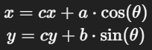

}
Lab19
Array of Polkadots
Objective
Multiple polkadots in arrays.
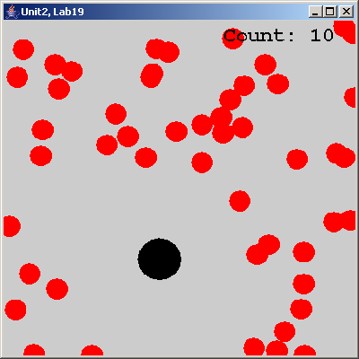
Background
Here is declaration of a Polkadot reference:
private Polkadot pd;
Here is the instantiation of the Polkadot object using the 4-arg constructor:
int x = (int)(Math.random() * N);
int y = (int)(Math.random() * N);
pd = new Polkadot(x, y, 25, Color.red);
Obviously, if we want 50 polkadots on the panel, we will want to use an array of polkadots. We need to declare the array reference:
private Polkadot[] myPDarray;
And then create 50 objects in the panel's constructor with:

myPDarray = new Polkadot[50];
for(int k=0; k<myPDarray.length; k++)
{
x = (int)(Math.random() * N);
y = (int)(Math.random() * N);
myPDarray[k] = new Polkadot(x, y, 25, Color.RED);
}

As you know, Polkadot objects know how to draw themselves. You will have to have each polkadot draw itself in the panel's Listener method.

The panel will also need a new collide method, something with the header

public void collide(Ball b, Polkadot[] myPDarray)
This method will have to visit each polkadot and check to see if the distance between the ball and that polkadot is less than the sum of their respective radii.

Specification
Copy all files from Lab12. Modify PrizePanel to make an array of 50 (or 100, or 1000) polkadots. As before, when the ball hits a polkadot, the polkadot jumps to a new position.
Create Unit2\Lab19\Driver19.java. Create an appropriate driver.
Sample Run
Unit2Lab19.jar

Lab20
Array of Prizes
Objective
Polkadots, balls, and arrays, all re-written.
Spot
int x, y, r
Color c
boolean intersect(Spot)
void drawme(Graphics)

Background
At every step of the way, the author could have made different design decisions, both large and small. For example, here is an alternative hierarchy:

Prize
void lightup()

Pinball
int dx, dy
int rightEdge, leftEdge
void setbound(int, int)
void tick()
int littlerandom()

In this version, prizes change color (from red to yellow) when they are hit by the pinball.
In this version, pinballs don't bounce at the same speed. Instead, they bounce in the reverse direction at a different speed--a new, small random number.
Here is the actionPerformed method of this version of PrizePanel:
119 private class Listener implements ActionListener
120 {
121 public void actionPerformed(ActionEvent e)
122 {
123 buffer.setColor(Color.WHITE);
124 buffer.fillRect(0,0,N,N);
126 for(int k=0; k<num; k++)
127 {
128 if(pb.intersect(array[k]))
129 array[k].lightup();
130 array[k].drawme(buffer);
131 }
133 pb.tick();
134 pb.drawme(buffer);
136 repaint();
137 }

Specification
Write Spot.java, Prize.java, and Pinball.java to the specifications shown above.
Create Unit2\Lab20\PrizePanel.java. Write the panel. The Listener code is given above.
Create Unit2\Lab20\Lab20.java. Create the driver.
Sample Run
Unit2Lab20.jar

